# 

# PRACTICAL NO 1

**Aim: Define a simple services like Converting Rs into Dollar and Call it from different platform like JAVA and .NET** **Java Steps:**

1. **Start NetBeans 8.2, Create a new project by selecting File > New Project > Java Web > Web Application.**

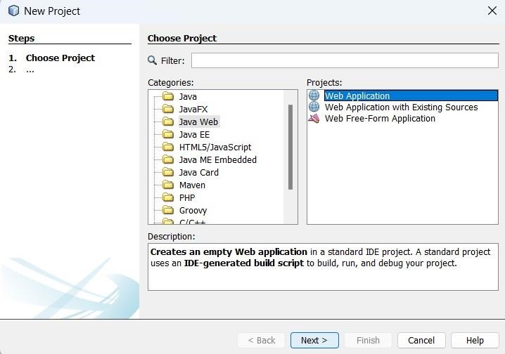

1. **Enter the project name and click on finish.**

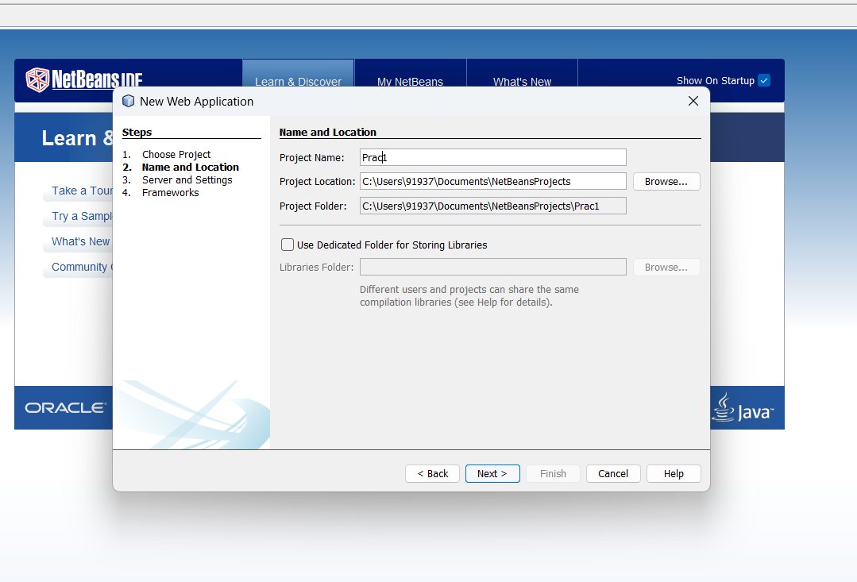

1. **Right click on the project in the directory view, New > Web Service.**

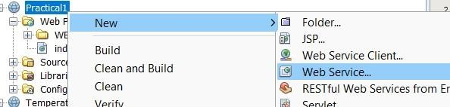

1. **Give the web service name, package name and click on finish.**

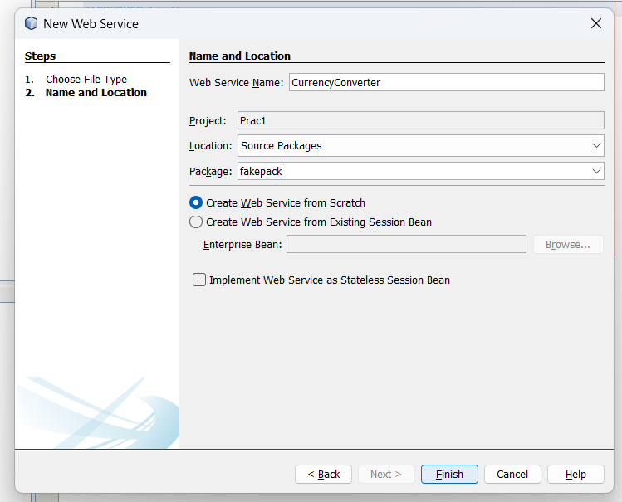

1. **Open the cuurencyconverter.java file for the created Web Service. Remove the default ‘hello’ method.**

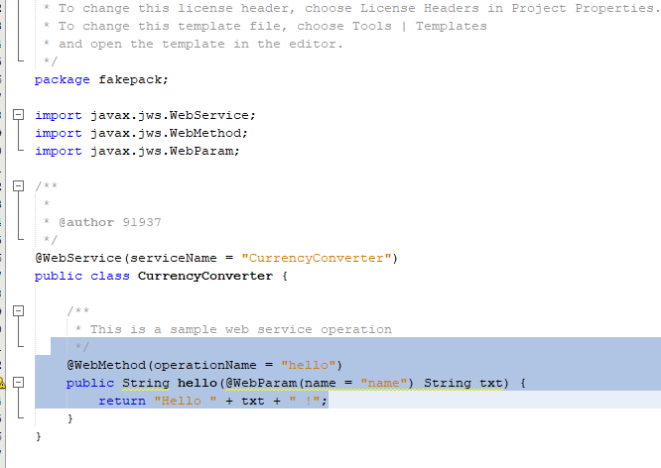

1. **Right click on an empty line, select Insert Code. Then select Add web service operation.**

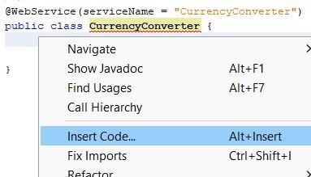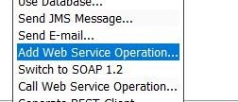

1. **Give the operation a name and return type. Then Add a new parameter, and give it a name and return type.**

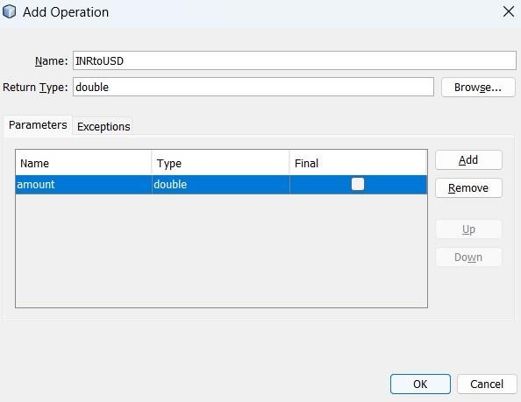

1. **Edit the generated code as required, here we divide amount by 83.11 which is the current conversion rate for INR to USD.**

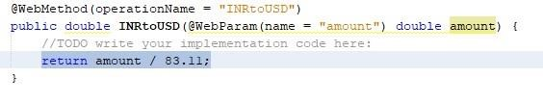

1. **Right click on Web Pages in the directory view, New > JSP.**

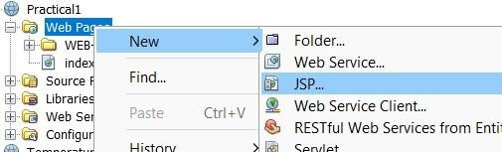

1. **Give it the name convert and click on finish.**

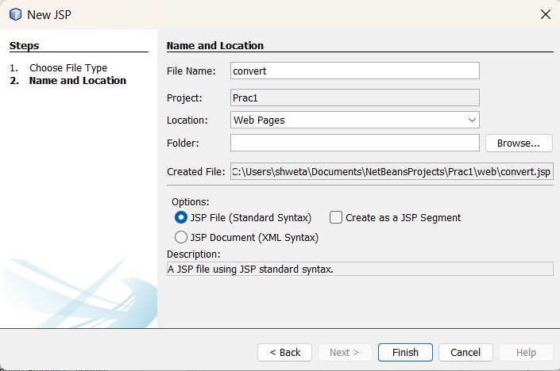

1. **Edit your index.html to create a form for currency conversion**.

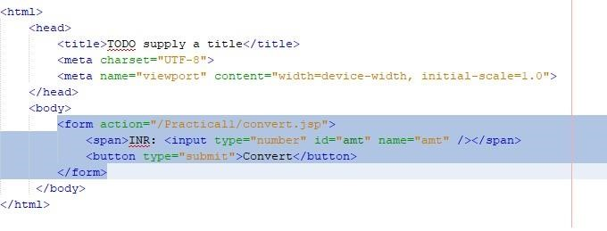

**Changes which has to be made**:

<body>

<form action="/Practical1/convert.jsp">

<span>INR: <input type="number" id="amt" name="amt" /></span>

<button type="submit">Convert</button>

</form>

**12)Save your files and click on the run button to generate files required for the next steps.**

-Once you run you’ll see browser like below:

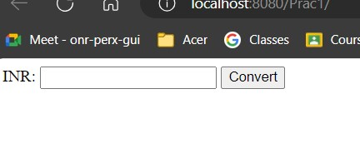

1. **Right click on Web Pages in the directory view, New > Web Service Client.**

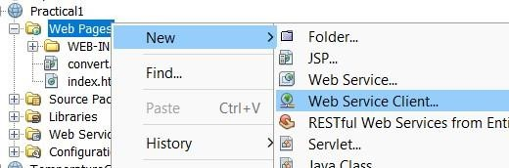

1. **Browse the previously created Web Service ‘CurrencyConverter’ and click on OK**.

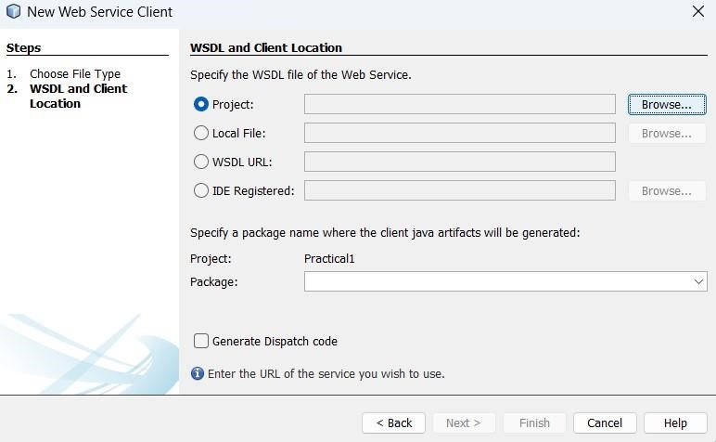

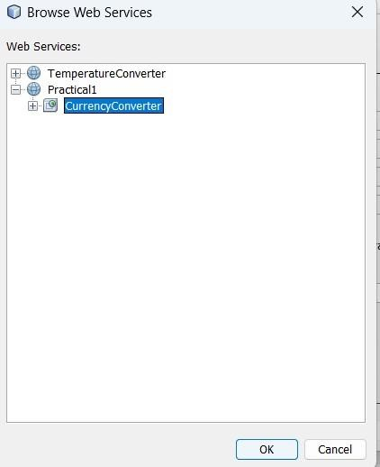

1. **Give it a package name different from the service package name and click on finish.**

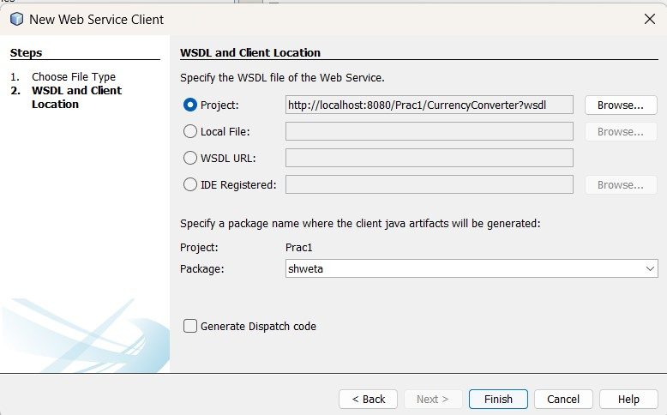

1. **Edit your convert.jsp file. Remove all content in the body tag.**

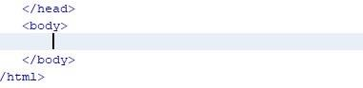

1. Then right click on an empty line and select Web Service Client Resources > Call Web Service Operation.

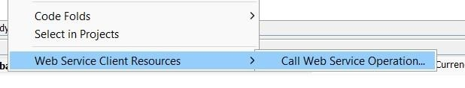

1. **Select the operation we created previously and click ok.**

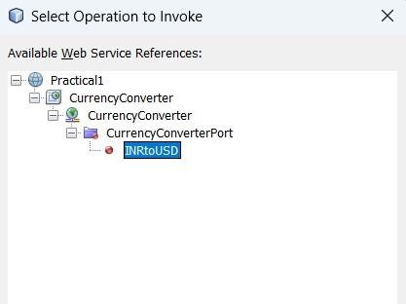

1. **It will generate code similar to the following.**

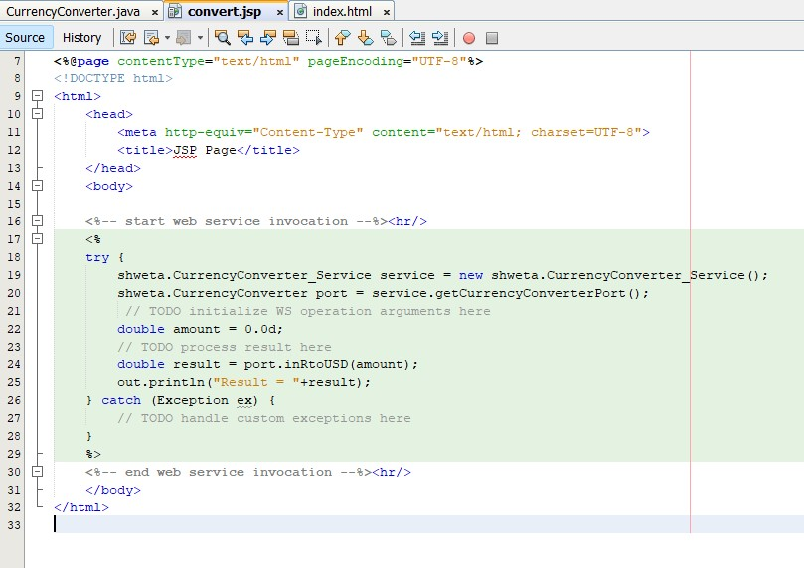

1. **Edit the convert.jsp code as required, here we get the amt parameter, convert it to a double and then use our service to convert the value from INR to USD.**

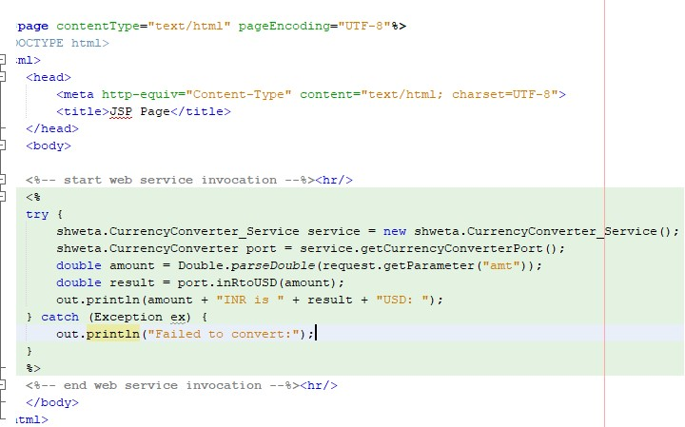

-Changes need to be made in convert.jsp:

<%-- start web service invocation --%><hr/>

<%

try {

shweta.CurrencyConverter_Service service = new shweta.CurrencyConverter_Service();

shweta.CurrencyConverter port = service.getCurrencyConverterPort(); double amount = Double.parseDouble(request.getParameter("amt")); double result = port.inRtoUSD(amount); out.println(amount + "INR is " + result + "USD: ");

} catch (Exception ex) { out.println("Failed to convert:");

}

%>

<%-- end web service invocation --%><hr/>

**21) We can now run the project and test it by entering a value and clicking convert.**

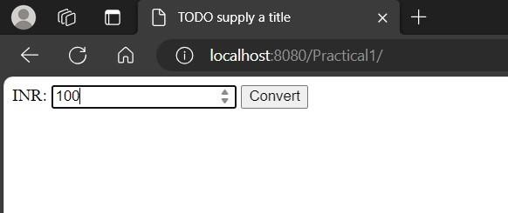

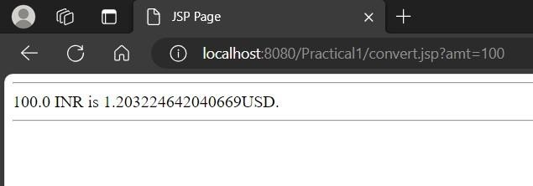

**Python Client Steps**

1. **Install the zeep python package with: pip install zeep.**

**:** 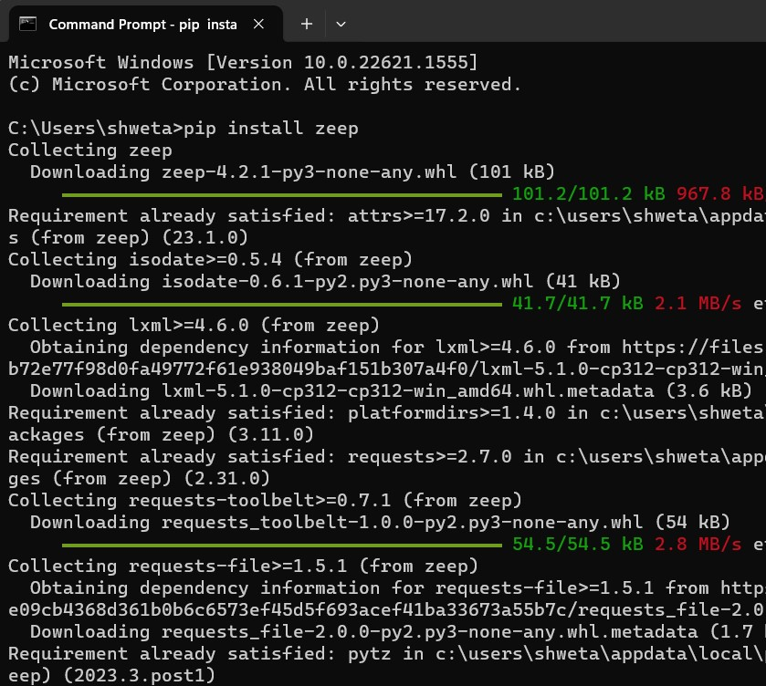

1. **Run the following python code. (Make sure to edit the wsdl url as needed)**

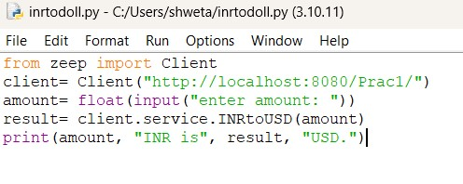

**Output:**

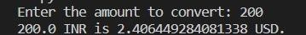

**C# Client Steps:**

1. **Create a new project in Visual Studio with the Console Application template**.

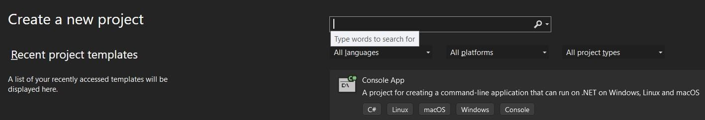

1. **Give it a name, click Next and then Create.**

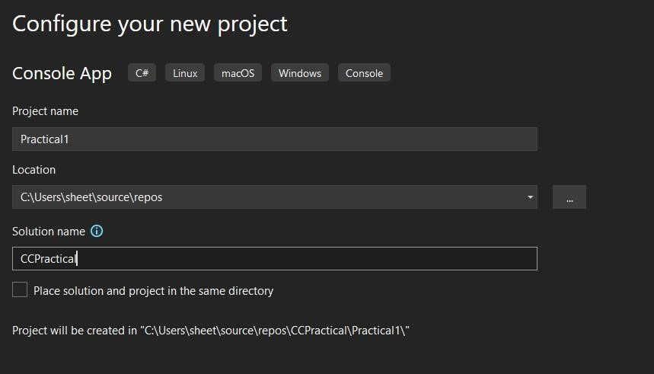

1. **Right click on the Project, Add > Service Reference**.

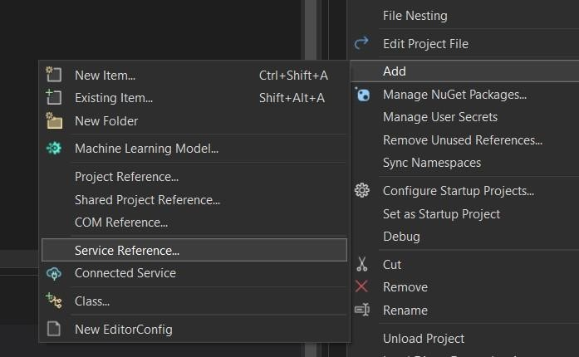

1. **Then select WCF service and click next.**

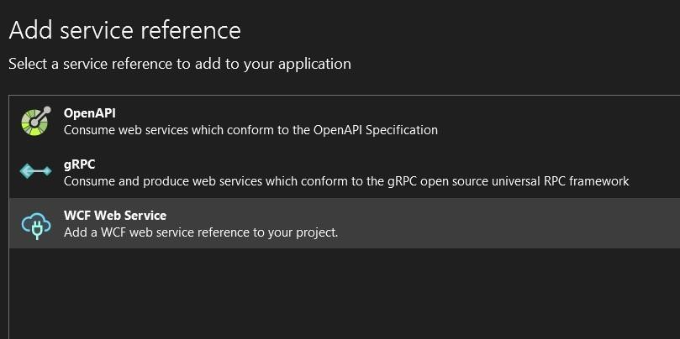

1. **Enter the wsdl URI and click next, it will generate the required files**.

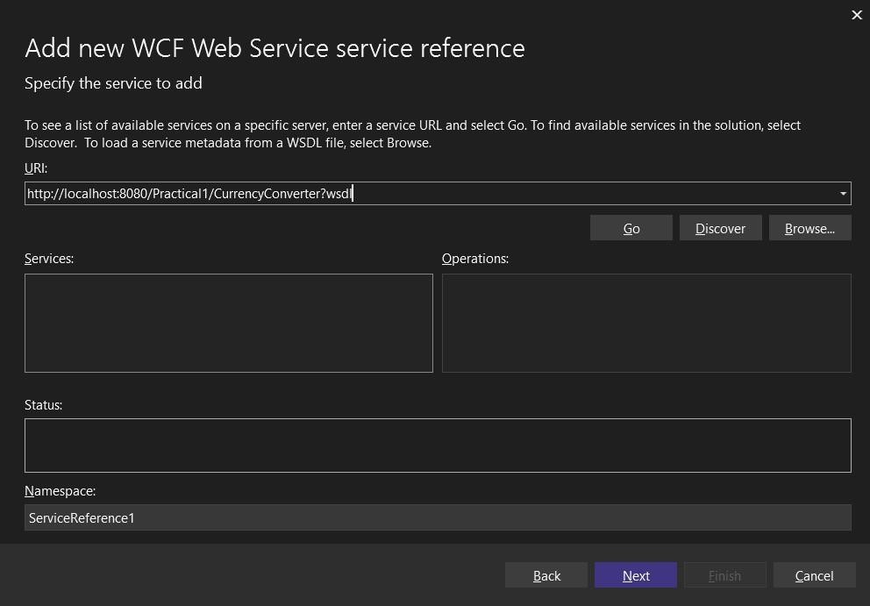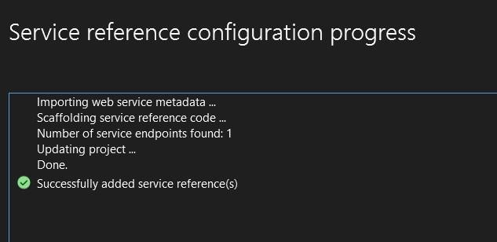

1. **Write the following code to access the web service in program.cs file.**

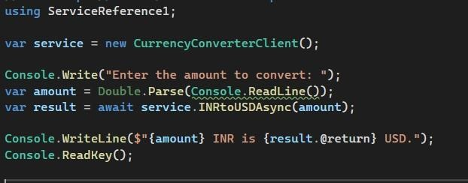

using ServiceReference1;

var service = new CurrencyConverterClient();

Console.Write("Enter the amount to convert: "); var amount = Double.Parse(Console.ReadLine()); var result = await service.INRtoUSDAsync(amount); Console.WriteLine($"{amount} INR is {result.@return} USD.");

Console.ReadKey();

1. **Click on run to test the code.**

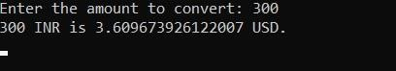

**PRACTICAL NO 2**

**Introduction:**

SOAP (Simple Object Access Protocol) is a widely used messaging protocol for exchanging structured information in the implementation of web services. In this example, we'll develop a simple SOAP web service that facilitates temperature conversion between Celsius and Fahrenheit scales. Temperature conversion is a common requirement in various applications, especially in scientific, engineering, and weather-related domains. By creating this SOAP service, we provide a standardized interface for clients to perform temperature conversions seamlessly.

**Service Description:**

Our SOAP service exposes two operations: celsiusToFahrenheit and fahrenheitToCelsius. Clients can invoke these operations by sending SOAP requests with temperature values in either Celsius or Fahrenheit scale. The service will perform the conversion and return the result to the client in the requested scale.

**Implementation Details:**

**WSDL Definition:** We'll start by defining the service interface using Web Services Description Language (WSDL). The WSDL will specify the operations offered by the service, including input parameters (temperature values) and output parameters (converted temperature values).

**Service Implementation:** Once the WSDL is defined, we'll implement the service logic in Java. We'll create Java classes representing the service operations and handle incoming SOAP requests. The conversion logic for Celsius to Fahrenheit and vice versa will be implemented in separate methods within the service class.

**Endpoint Configuration:** Next, we'll configure the SOAP service endpoint to specify the URL where clients can access the service. This involves setting up servlet mappings and configuring the service runtime environment.

**Deployment:** Finally, we'll deploy the SOAP service to a servlet container like Apache Tomcat or a Java EE application server. Once deployed, clients can send SOAP requests to the service endpoint, specifying the temperature value and the desired conversion operation.

**Program**: To create a Simple Web Service that converts the temperature from Celsius to Fahrenheit and vice versa.

**STEPS:**

1. **Create a Web Application: File > New Project > Java Web > Web Application > Next.**

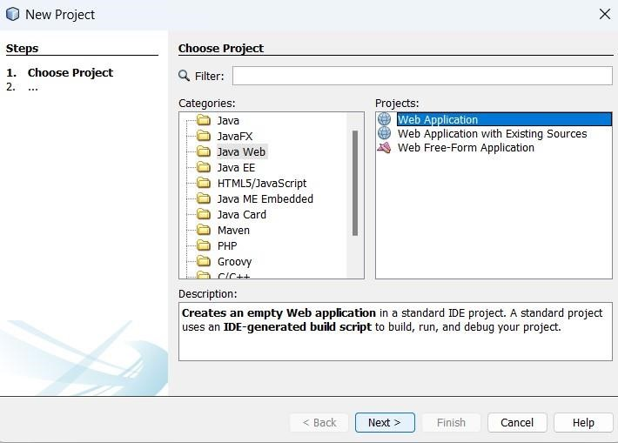

-Give the Project Name as TemperatureConverter and click on Next

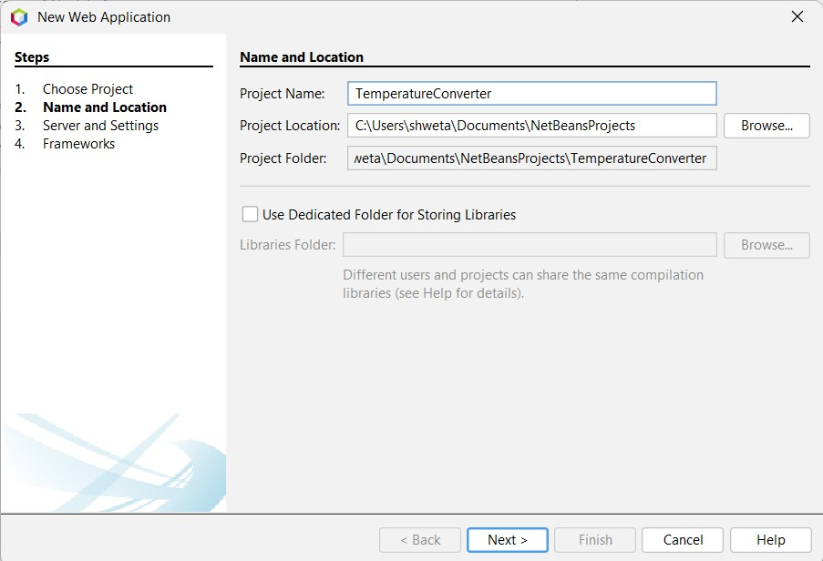

**-**Server should be GlassFish Server 4.1.1 and then click on Finish

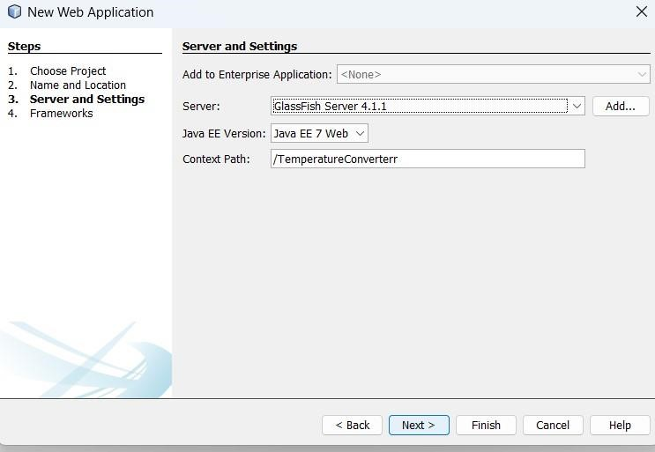

-Now delete the index.html file which is auto created

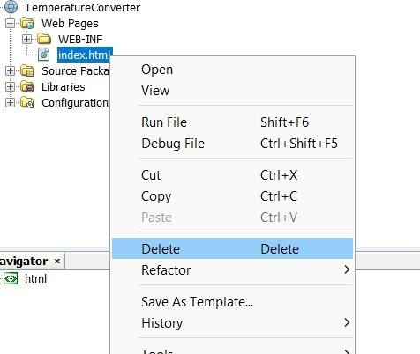

1. **Create a Web Service in that project: Right Click on Project Name > New > Web Service**.

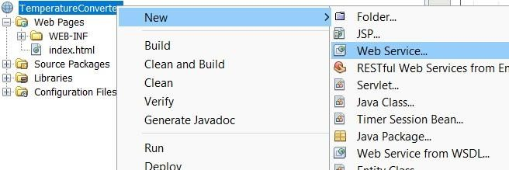

-Name the webservice name as tempwebservice and package name as temperature > Finish

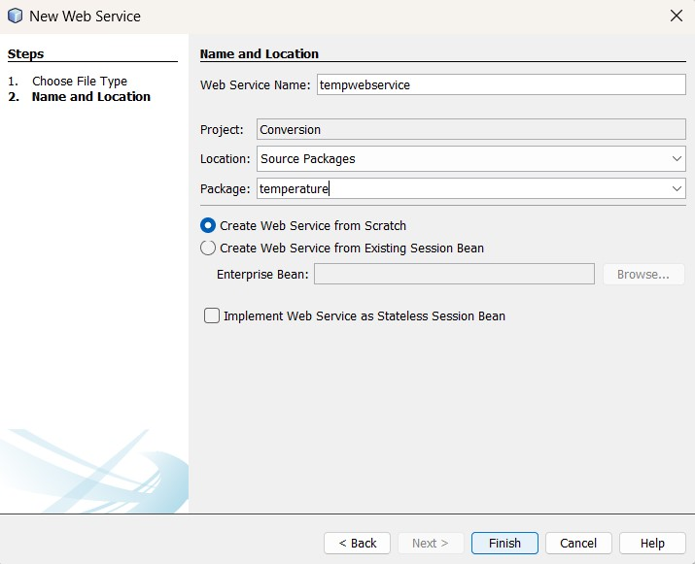

-Now a java file is created as tempwebservice.java

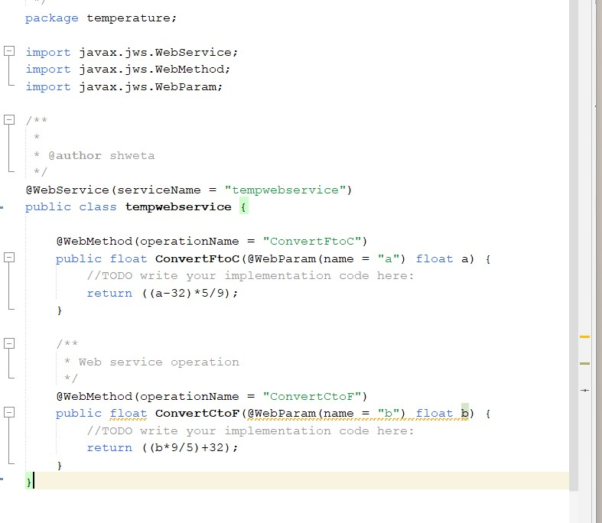

1. **As we have created our WEB SERVICE (i.e. tempwebservice), WE’LL NOW ADDSOME FUNCTIONALITIES (i.e. temperature conversion methods). So, in the class tempwebservice, add 2 methods by doing:**

-Right Click on the java file page > Insert Code > Add Web Service Operation…

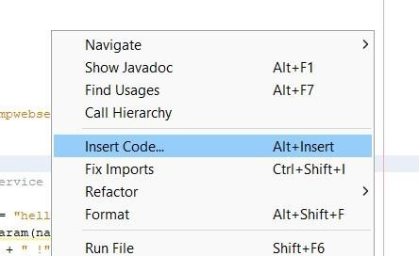

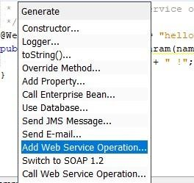

-Give the name as ConvertFtoC, Return type as float, add the below given parameter and click on ok

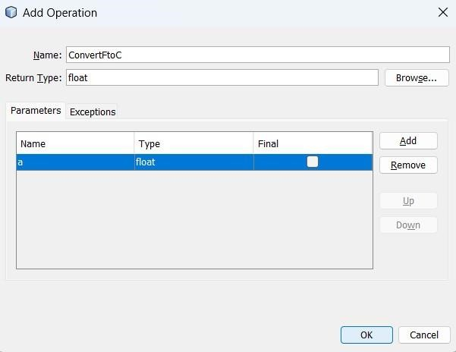

-Now you can see web service operation is added in the java file and make changes as given below. return ((a-32)*5/9);

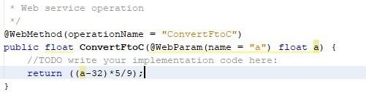

-Following the same steps add one more operation as given below

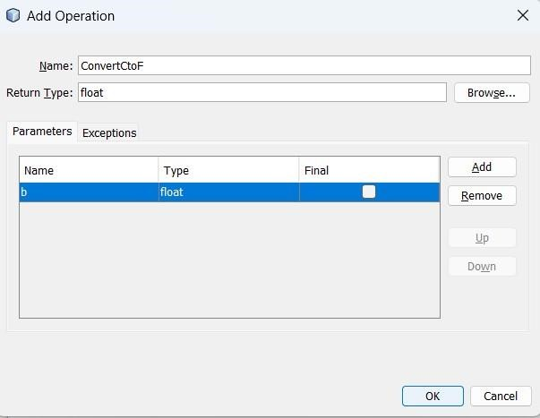

-Again make changes as given below in the recently added operation:

return ((b*9/5)+32);

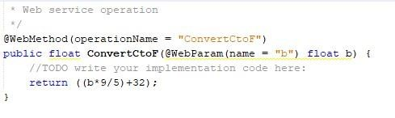

**Source Code (tempwebservice.java):** /* package ty; import javax.jws.WebService; import javax.jws.WebMethod; import javax.jws.WebParam;

/**

*

* @author shweta

*/

@WebService(serviceName = "temperature") public class temperature {

@WebMethod(operationName = "ConvertCtoF") public float ConvertCtoF(@WebParam(name = "a") float a) {

//TODO write your implementation code here:

return ((a*9/5)+32) ;

}

/**

* Web service operation

*/

@WebMethod(operationName = "ConvertFtoC") public float ConvertFtoC(@WebParam(name = "b") float b) { return ((b-32)*5/9);

} }

1. **Compile, click on (F9)**

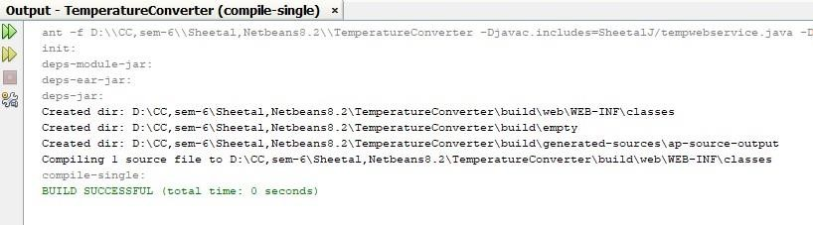

1. **Now deploy it, (right click on Project Name > Deploy).**

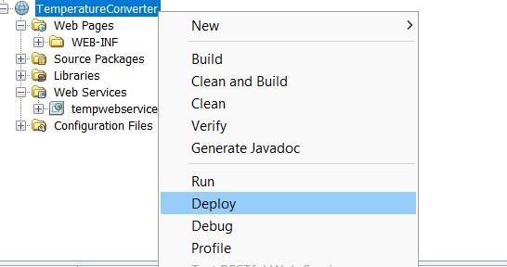

1. **If problem in deployment occurs i.e. it does not shows Build successful in the output section then follow the below steps.**

-Open command prompt then type: netstat -aon | find ":8080" | find "LISTENING" -You will see result somewhat like this:

-Copy the PID from here “25272”

-Open task manager > Details > in the search bar paste the PID “25272”, you will find the particular process which is running.

-Right click on the process and choose End process tree.

1. **After all these done, deploy the project again and it will be successfully deployed.**

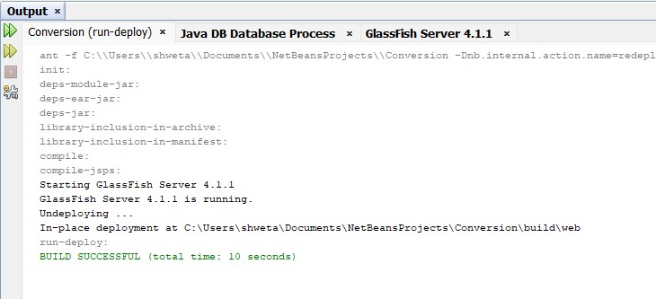

**8) Now we’ll test our web service:**

-So navigate to: Projects > Project Name > Web Services > right click on temperature > click Test Web Service > (the browser will open).

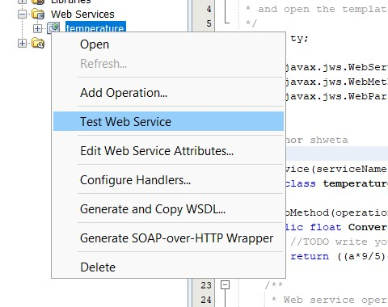

-temperature here is a WSDL file.

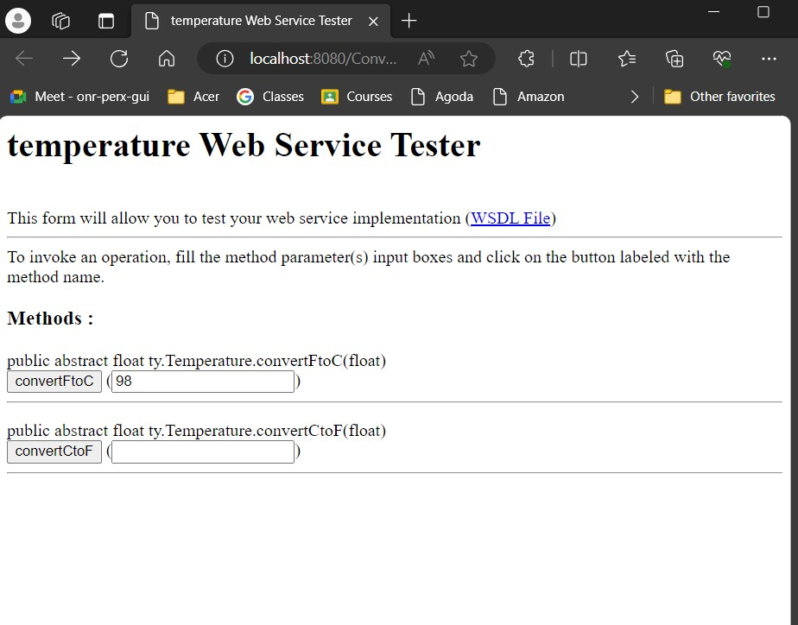

**Perform Conversions:**

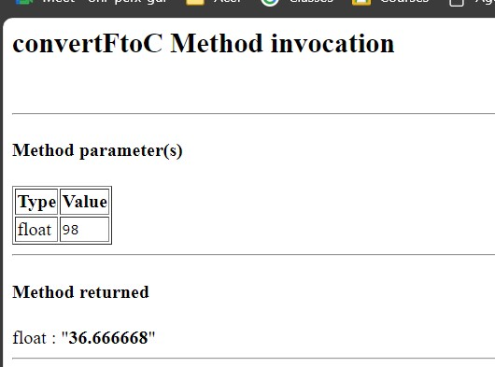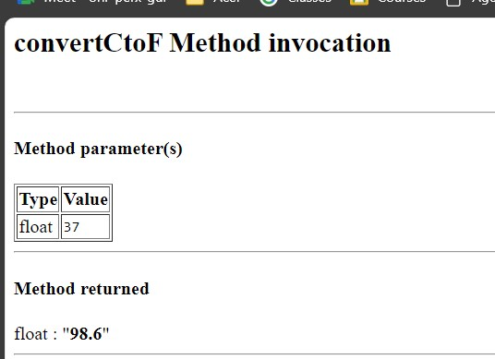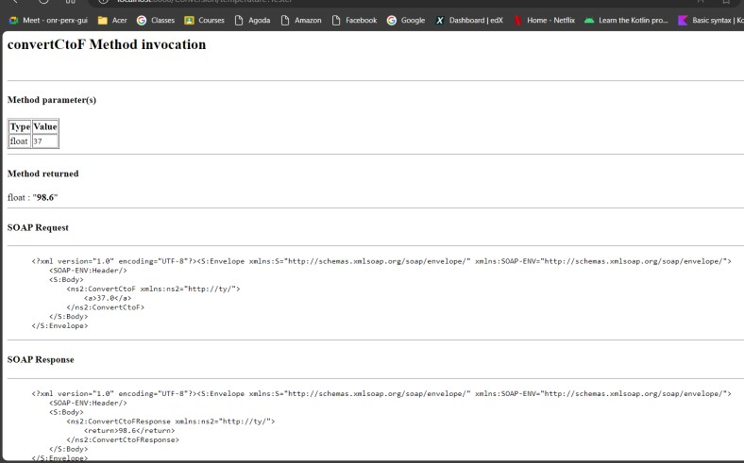

**Now we’ll be using the created Web Service(i.e. temperature) by creating our WEB SERVICE CLIENT.**

Web Services > Web Service Client… > Browse your Project Name and select WSDL file > Add Package Name: ShwetaB > Finish.

*(NOTE THAT: the package we first created in WEB SERVICE (i.e. ty) will now be linked to our created package in CLIENT (i.e. tycs). We can also see the Generated Sources in the Solution Explorer. We will further use this new package name for the rest.)*

- Right Click on Project Name > New > Other

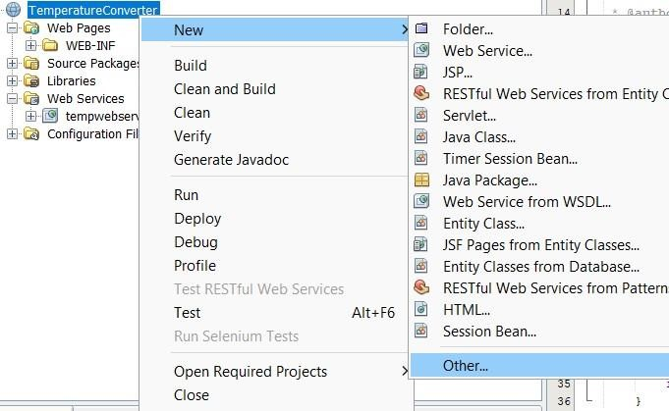

-In categories choose web services > In File Types choose Web Service Client > Next

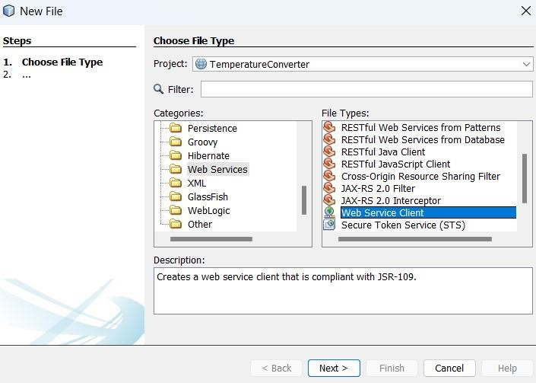

-Browse the tempwebservice file

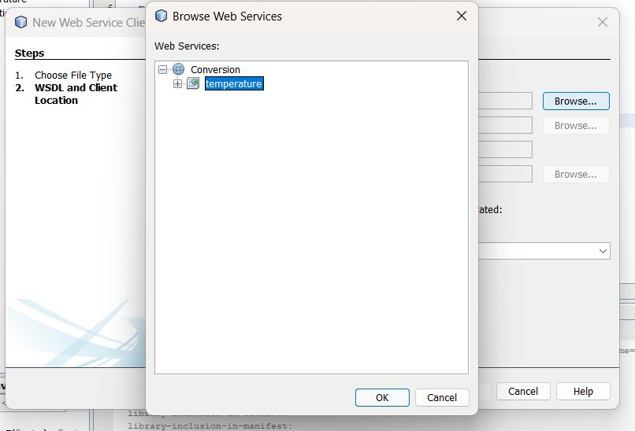

-In WSDL URL paste the url from the browser where you performed operations and change the last word from tester to wsdl.

-Also give package name “tycs”

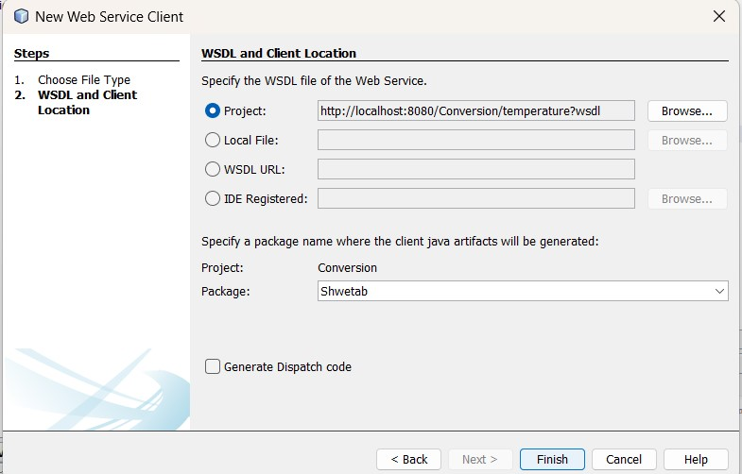

**11)Now to make front page, we need to create a JSP file.**

-So, Right Click on Project Name > New > JSP

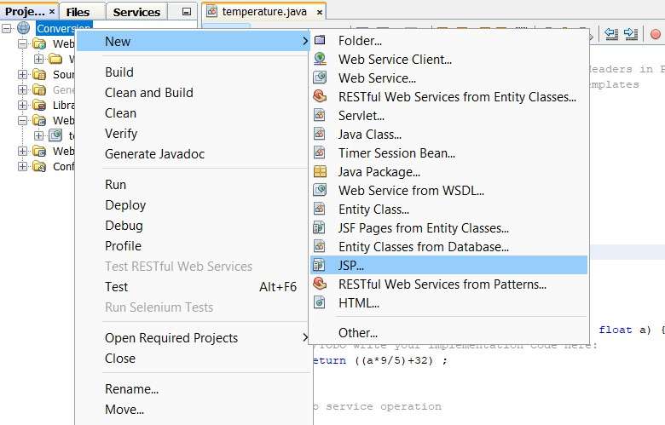

-Give the file name as index and click on finish.

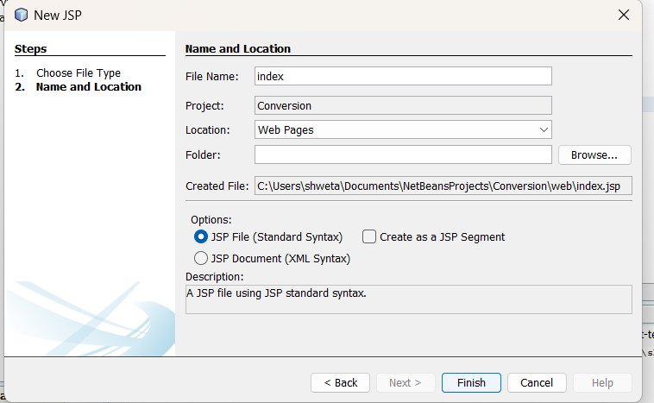

-Make the required changes in index.jsp file.

**Source code (index.jsp):**

<%--

Document : index

Created on : 31 Jan, 2024, 9:08:13 PM

Author : aryan

--%>

<%@page contentType="text/html" pageEncoding="UTF-8"%>

<!DOCTYPE html>

<html>

<head>

<meta http-equiv="Content-Type" content="text/html; charset=UTF-8">

<title>JSP Page</title>

</head>

<body>

<form action="indexaction.jsp" method="POST">

Enter Temperature:

<input type="text" name="txt" value="" />

<input type="submit" value="Convert" name="convert" />

</form>

</body>

</html>

**12) Now to create the action behind that, we’ll create another JSP file, with a name that is declared in the previous JSP file.**

So, Right Click on Project Name > New > JSP > File Name: indexaction > Finish. Then add some under body tag.

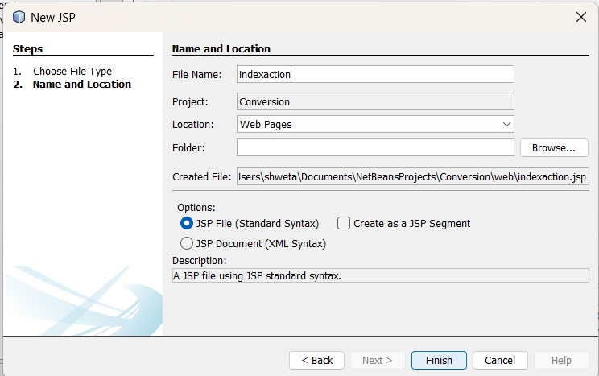

**Source code: indexaction.jsp**

<%--

Document : indexaction

Created on : 31 Jan, 2024, 9:10:16 PM

Author : aryan

--%>

<%@page contentType="text/html" pageEncoding="UTF-8"%>

<!DOCTYPE html>

<html>

<head>

<meta http-equiv="Content-Type" content="text/html; charset=UTF-8">

<title>JSP Page</title>

</head>

<body>

<% tycs.Tempwebservice_Service obj = new tycs.Tempwebservice_Service(); tycs.Tempwebservice port= obj.getTempwebservicePort(); String val=request.getParameter("txt"); //took the input float temp=Float.parseFloat(val); //parse the input variable to float float result1= port.convertFtoC(temp); float result2= port.convertCtoF(temp);

out.println("Temperature conversion from F to C: "+result1);

%>

<br> <% out.println("Temperature conversion from C to F:"+result2);

%>

</body>

</html>

**13) Now RUN “index.jsp” file.**

**OUTPUTS:**

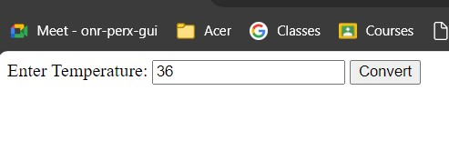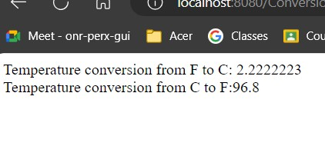

**Conclusion:**

By creating this simple SOAP web service for temperature conversion, we provide a convenient and standardized way for clients to perform temperature conversions between Celsius and Fahrenheit scales. This service demonstrates the power of SOAP-based web services in enabling interoperability and seamless communication between distributed systems. Developers can easily integrate this service into their applications to meet their temperature conversion needs.

# PRACTICAL NO 3

**Aim:** Create a simple Rest Service.

**Program:** Demonstrate CRUD operations with suitable database using RESTful Web Service.

1. **To start the Java DB Database from NetBeans, perform the following steps**.
   1. Click **Services** tab.
   2. Expand **Databases** node.
   3. Right-click **Java DB** icon.

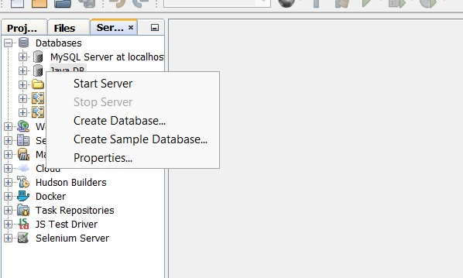

Note the following output in the Output window, indicating that the DB server has started:

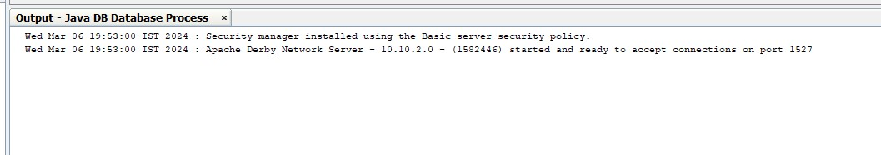

Note that the DBserver version could vary from the version shown in the screenshot depending on the JDK build updates.

1. **To create playerDB database, perform the following steps:** 
   1. Right-click **Java DB** icon, select **Create Database**.

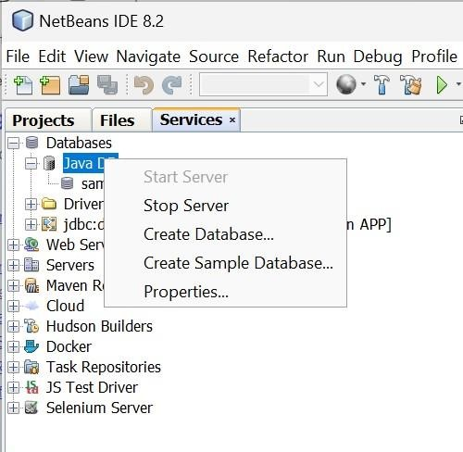

* 1. Enter the following information for the database:

Database Name: **playerDB**

User Name: **shweta**

Password: **1234**

Confirm Password: **1234**

This creates the database and adds a connection for the database under the **Databases** icon.

1. **To connect to the newly created database playerDB, perform the following steps :** 
   1. Right-click jdbc:derby://localhost:1527/playerDB connection.

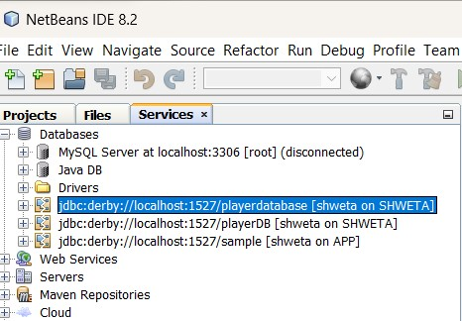

b.

s

elect

**Connect**

.

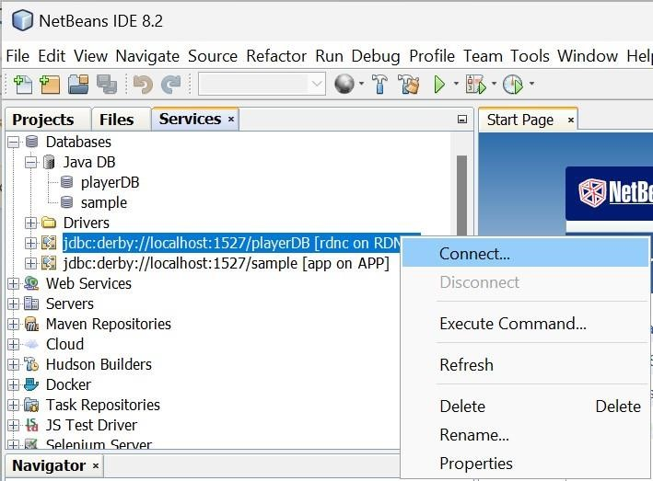

1. **Create tables and populate them with data in playerDB database.** 
   1. In NetBeans select File > Open File.

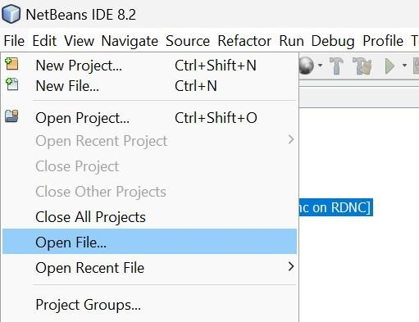

* 1. In the file browser navigate to the directory, where you unzipped the files from the [Prerequisites s](https://www.oracle.com/webfolder/technetwork/tutorials/obe/java/RESTfulWebServices/RESTfulWebservices.htm#s6)ection and select playersDB.sql.
  2. Click Open. The script automatically opens in the SQL Editor

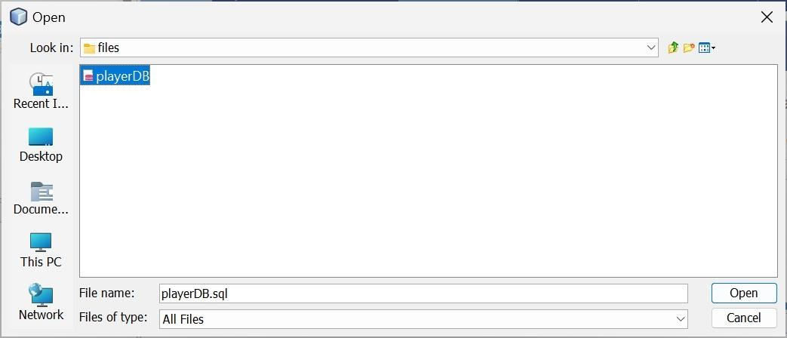

* 1. Select jdbc:derby://localhost:1527/playerDB in Connection drop-down box in the SQL Editor toolbar.
  2. Click the **Run SQL** icon to execute the SQL statement.

1. **Examine the contents of the database.** 
   1. In the **Services** window, expand the jdbc:derby://localhost:1527/playerDB connection under the Databases node.

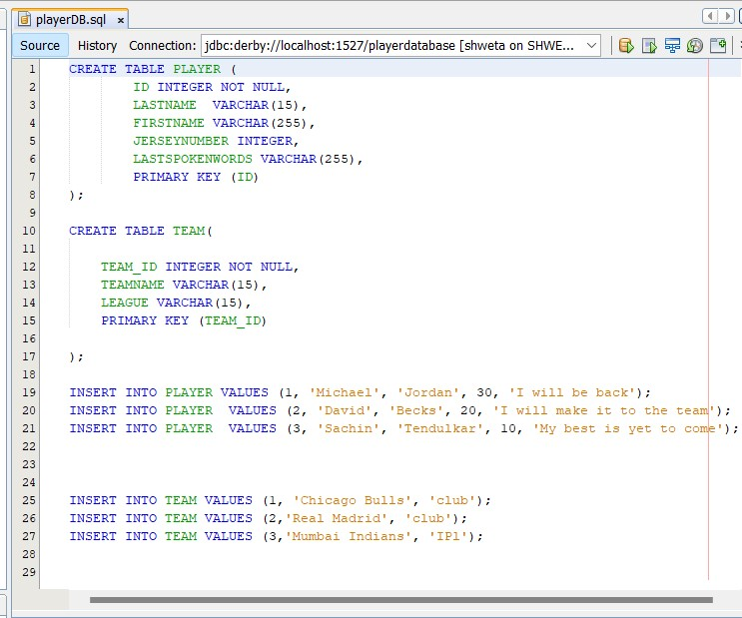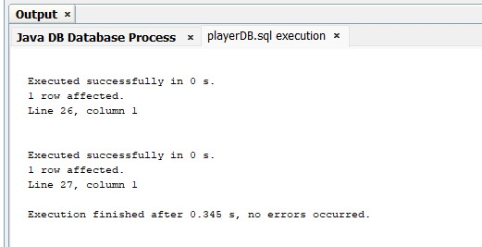

* 1. Right-click the connection and select**Refresh**.
  2. Expand the **rdnc** schema. You see the nodes for Tables, Views, and Procedures.

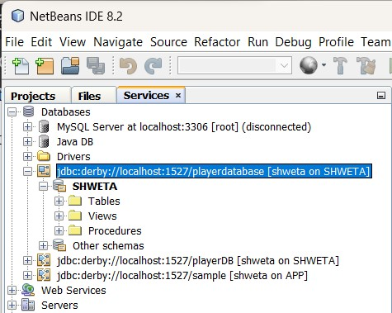

* 1. Expand the Tables node to see the PLAYER and TEAM tables.

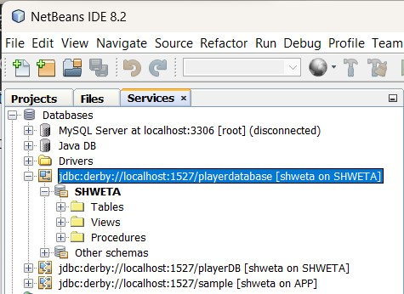

* 1. Right-click the PLAYER table node and select **View Data**.

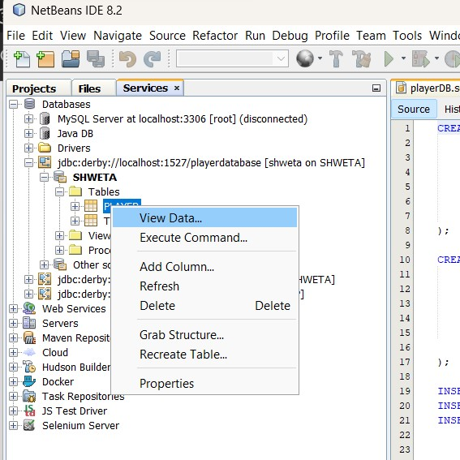

An SQL command window opens and executes an SQL command to display the data in the table.

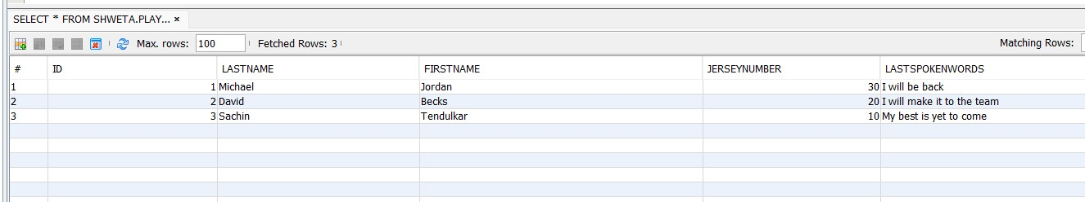

* 1. Repeat the previous step for the TEAM table.

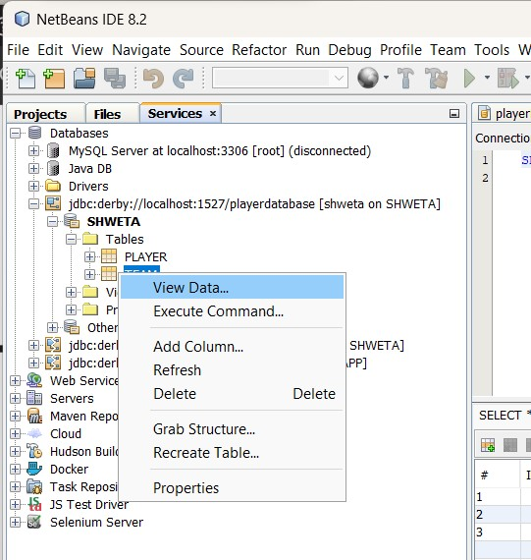

An SQL command window opens and executes an SQL command to display the data in the table.

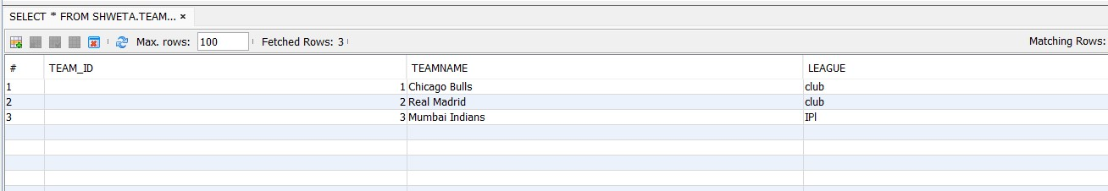

**Building a Sample Web Application**

To create RESTful Web Services, you need a Java Web application project. In the below section you will create a demo Java web project, PlayerServer.

1. **To create new Java Web Project, select File > New Project.**

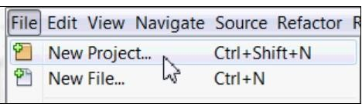

1. Select **Java** **Web** from the **Categories** column and **Web Application** from the **Projects** column and click **Next**.

a. Name the project

**PlayerServer**

.

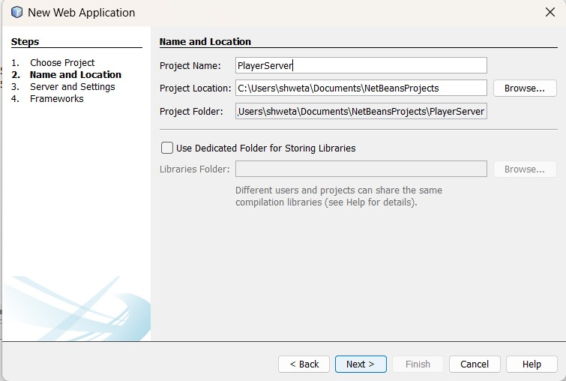

**3.**



**Perform the following steps:**

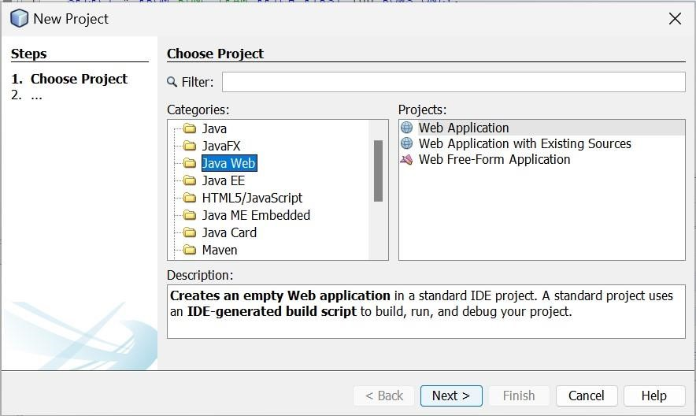

1. **In the Server and Settings window, verify GlassFish Server is selected as Server and click Finish.**

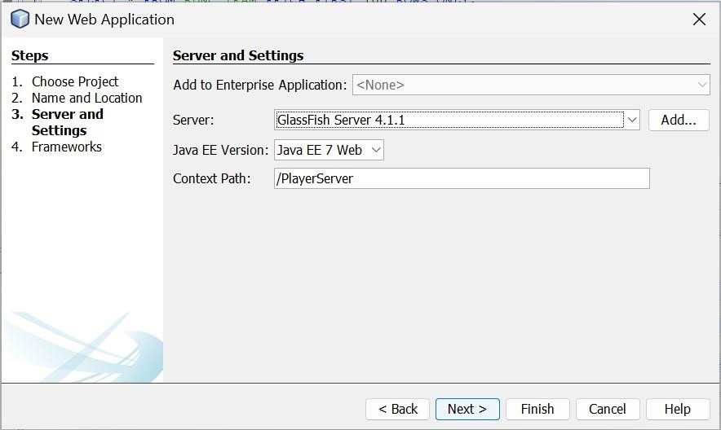

1. **To start the Server, perform the following steps** :
   1. Open the Projects tab.
   2. Right-click PlayerServer project.
   3. Select Run.

This action starts the GlassFish server and deploys the application.

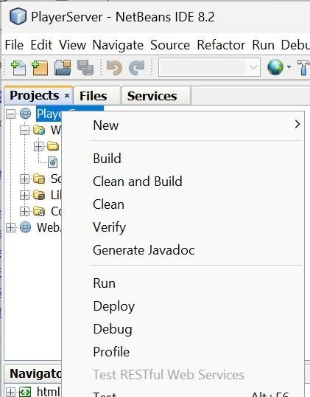

On successful deployment of the application - a default jsp page with url, http://localhost:8080/PlayerServer/ is opened in the browser displaying "Hello World".

**Generate RESTful Web Services**

* 1. **To generate RESTful Web Services do the following:**

Right-click the PlayerServer and choose **New > Other > Web Services > RESTful Web Services from Database**. The New RESTful Web Service wizard opens on the Database Tables panel.

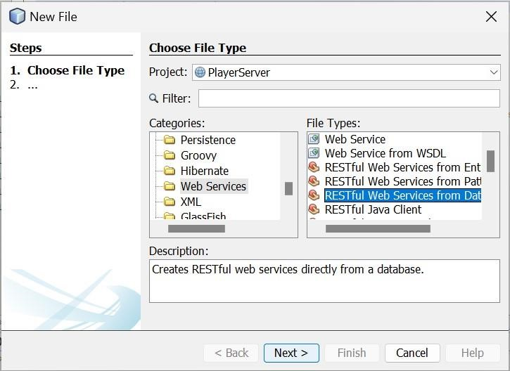

* 1. **In the Database Tables window, select Data Source.**

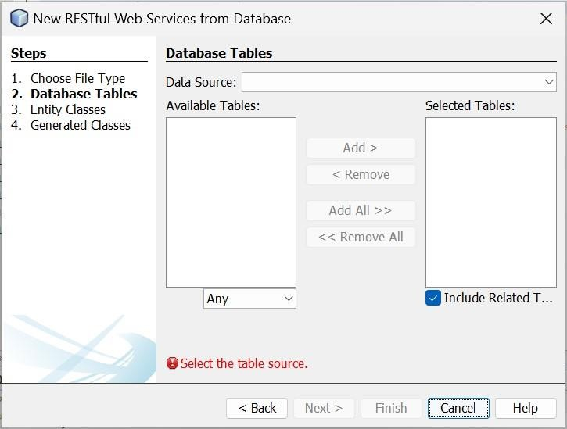

* 1. **Next select "New Data Source" from the Drop-down list.**

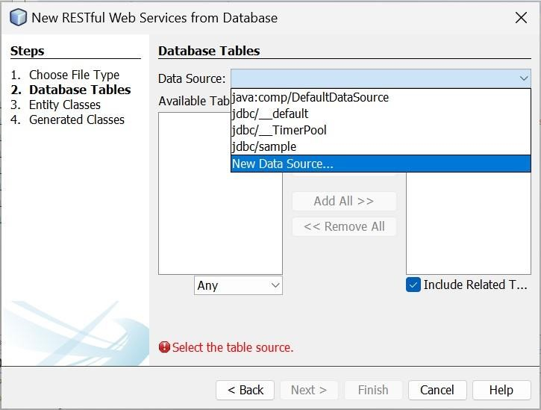

a. In the Create Data Source Window, enter the following information:

**JNDI name**: jdbc/playerdatabase

**Database connection :** select jdbc:derby://localhost:1527/playerdatabase[john on JOHN]

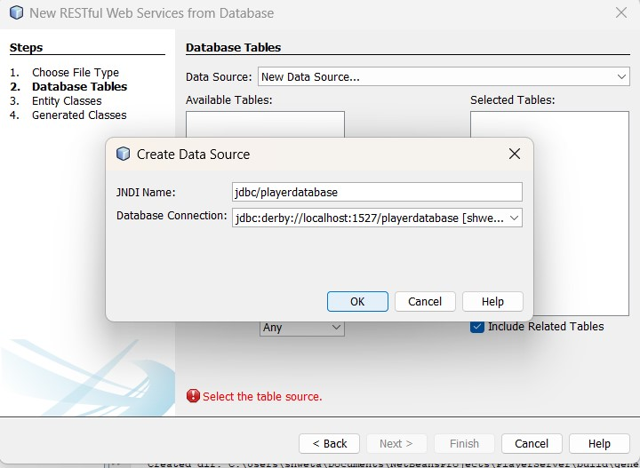

The PLAYER and TEAM tables are displayed under the Available Tables column.

c. Click **Add All**. The PLAYER and TEAM tables are displayed under the Selected Tables column.

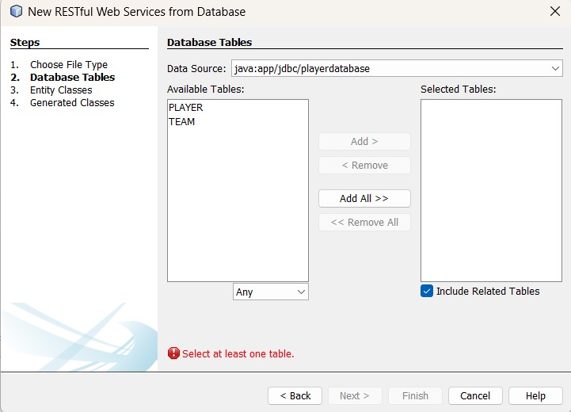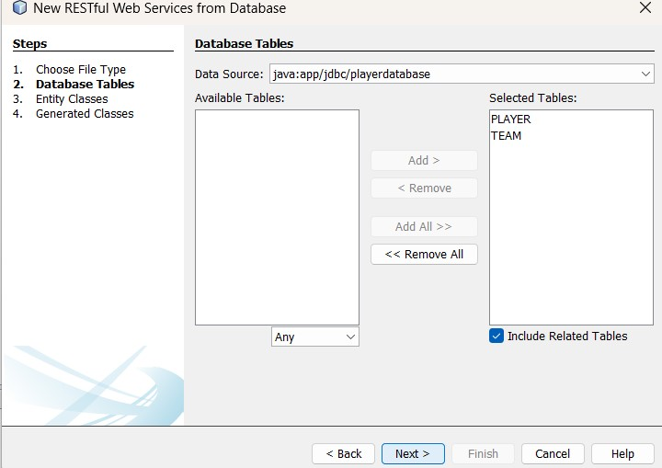

**4. In the Entity Classes window, complete the following steps:**

a. Enter the package name as com.playerentity.

**5.**

**In the Generated Classes Window, click Finish with default values.**



b.



Click Next.

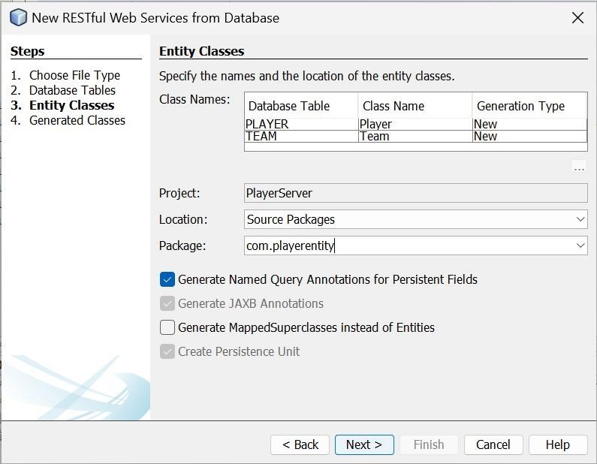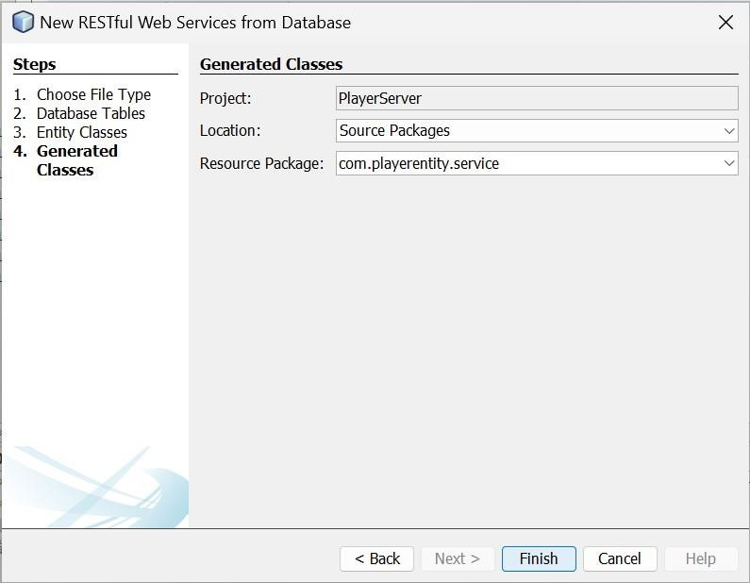

1. **In the Rest Resources Configuration Window, click OK.**

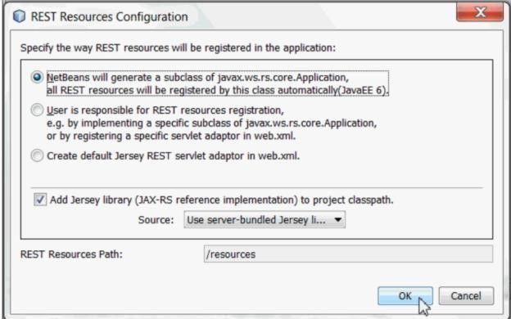

1. **In the Projects pane, perform the below steps** :
   1. Select and expand the **PlayerServer** project.
   2. Expand the **source packages** of the project.
   3. Expand the **com.playerentity** package.
   4. Verify the creation of Entity Classes **Player.java** and **Team.java**.

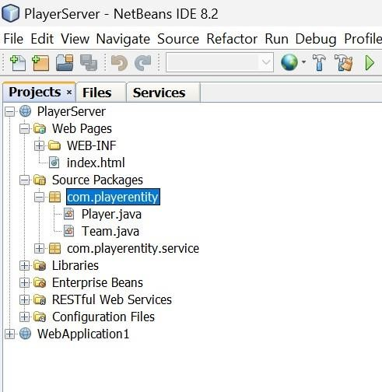

* 1. Expand the **RESTful Web Services folder** and and verify the creation of two

RESTful Web

Services PlayerFacadeREST[com.playerentity.player] and TeamFacadeREST[co m.playerentity.team].

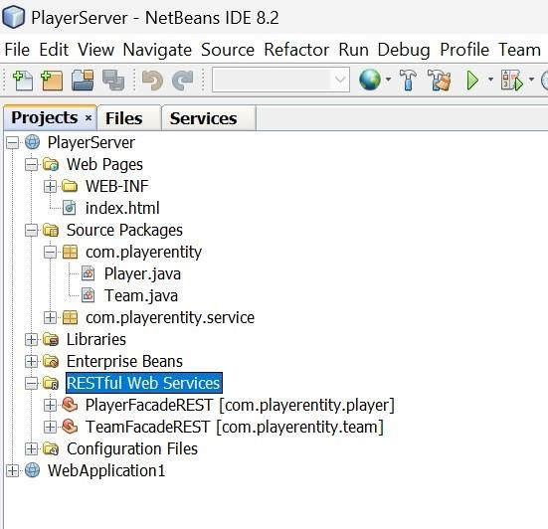

The above generated two Web Services are the REST front end of our application. For each entity, there is a resource that lists all the entity's instances.

**Test RESTful Web Services**

The following section demonstrates how to test RESTful Web Services with tests that are generated using the test framework provided by Jersey.

1. **To Generate Web Services Test client, complete the following steps.** 
   1. **Select** PlayerServer **project.**
   2. **Right-click and select** Test RESTful Web Services.

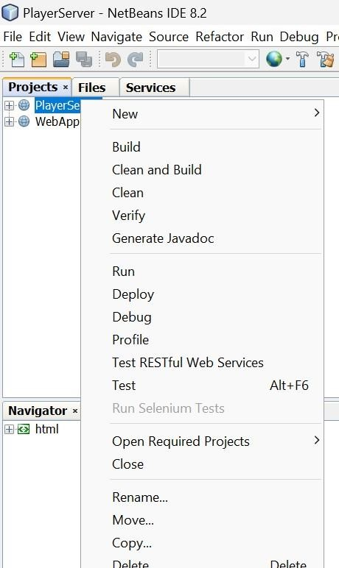

Configure REST test Client window opens as shown in the below screenshot.

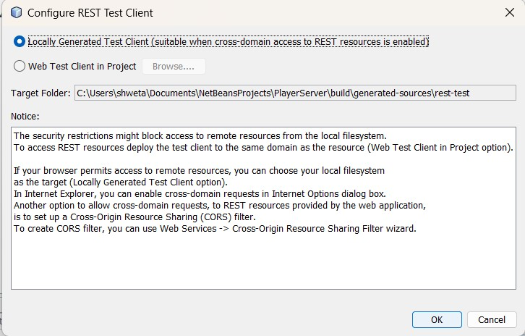

1. **Select "Web Test Client in project" and click Browse**.

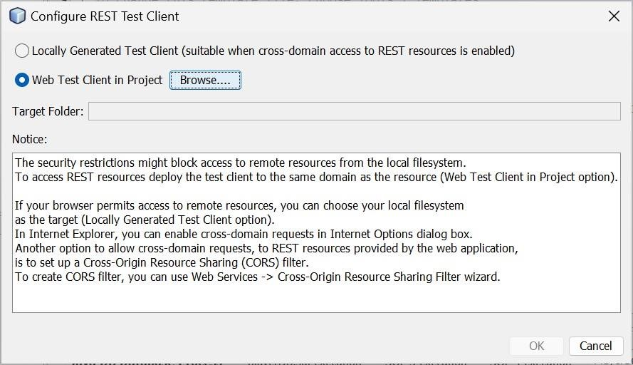

1. **a. In the Select Project dialog box, select PlayerServer and click OK.**

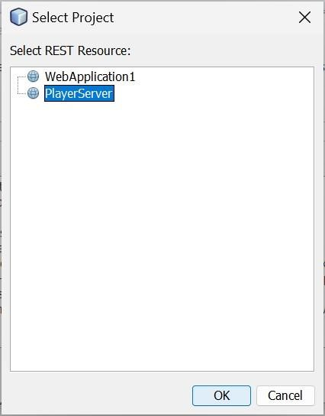

b. **Configure Rest Test Client window** is displayed, click OK.

The server starts and the application is deployed. When deployment is complete, the browser displays your application, with a link for each of the Web Services.

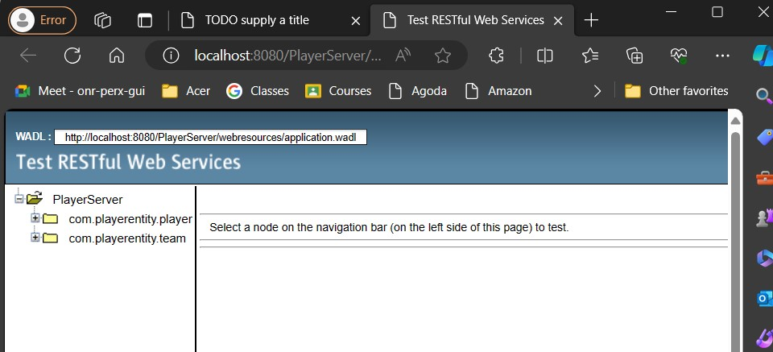

On the left-hand side is the set of root resources named **com.playerentity.team** and **com.playerentity.player**.

**4. To test the Web Services Client, complete the following steps.**

1. Select one resource node such as com.playerentity.team.
2. In the "Choose method to test" field, select either GET (application/json) or GET (application/xml).

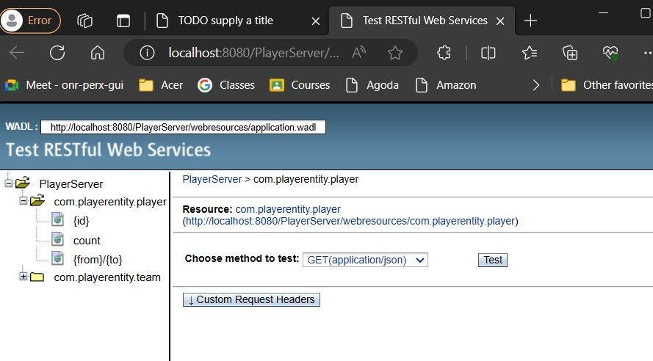

The test client sends a request and displays the result in the Test Output section. The test client displays the Raw View by default.

1. Examine the output:

Response to an application/xml request.

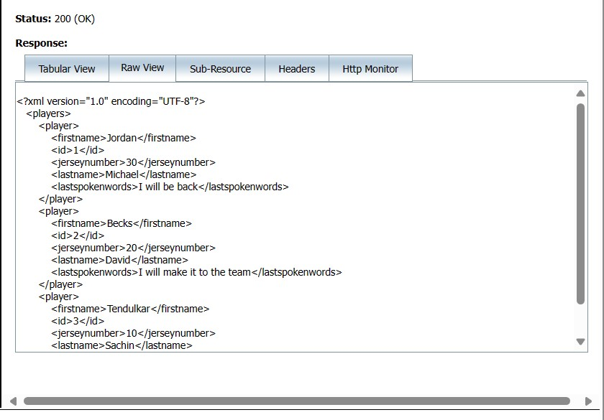

Response to an application/json request.

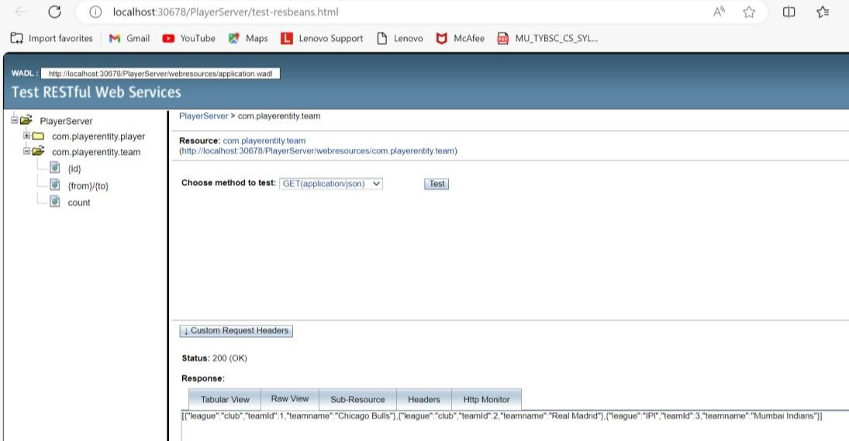

JSON is widely used in REST-based applications, because this format is more compact than XML. Also, it can easily be used with most common programming languages, including JavaScript.

1. Likewise select the com.playerentity.player node and test the Web Service

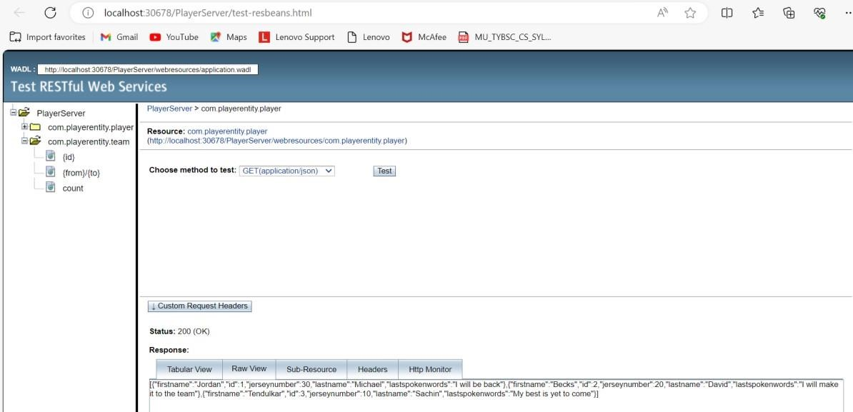

# PRACTICAL NO 4

**Aim**: Develop application to consume Google’s search / Google’s Map RESTful Web service.

**Python Code:**  import requests def get_geolocation(api_key, search_string): base_url = "https://us1.locationiq.com/v1/search" params = {'key': api_key,

'q': search_string,

'format': 'json',}

response = requests.get(base_url, params=params) data = response.json() if response.status_code == 200 and data: result = {

'place_id': data[0].get('place_id', ''),

'lat': data[0].get('lat', ''),

'lon': data[0].get('lon', ''),

'display_name': data[0].get('display_name', ''),

} return result else: print(f"Error: {response.status_code} - {data.get('error', 'No error message')}") return None

api_key = 'pk.e00e22c796c485d86f5d0a67fe7a2d13' search_string = input("Enter the location : ") result = get_geolocation(api_key, search_string) if result:

print("Output:") for key, value in result.items():

print(f"{key}: {value}")

**BROWSE LOCATION IQ>SIGNUP WITH EMAIL> CLICK ON THE LINK PROVIDED BY LOCATION IQ (on your email)>YOU WILL GET YOUR ACCESS TOKEN COPY THE KEY AND PASTE IN THE PYTHON CODE:**

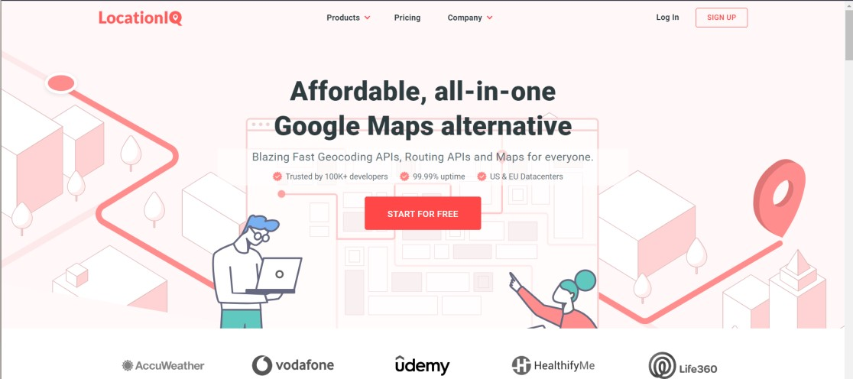

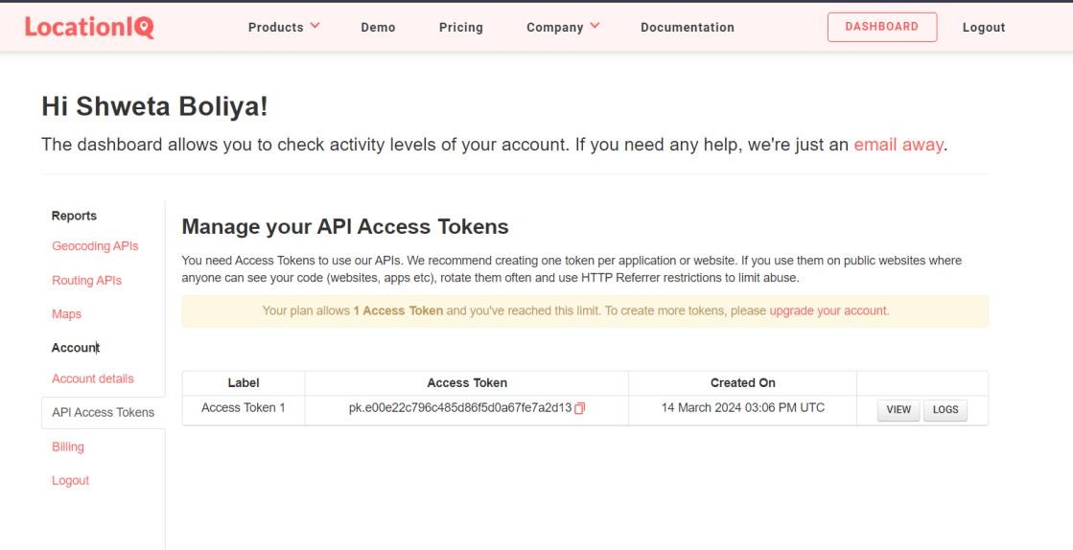

**Run the python code Output:**

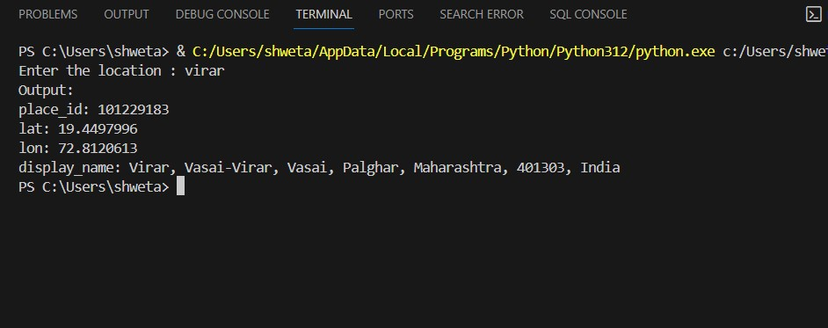

# PRACTICAL NO 5

**AIM: Installation and Configuration of virtualization using KVM.**

**Commands:**

1. sudo grep-c"svm\|vmx"/proc/cpuinfo
2. sudo apt install qemu-kvm libvirt-daemon-system virt-manager brid
3. sudo apt-get update
4. sudo apt-get install qemu-kvm libvirt-daemon-system virt-manager bridge-utils
5. sudo apt install qemu-kvm libvirt-clients libvirt-daemon-system bridge-utils
6. sudo systemctl start libvirtd
7. sudo usermod -aG kvm $USER
8. sudo systemctl is-active libvirtd
9. sudo usermod -aG libvirt $USER sudo usermod -aG kvm $USER
10. virt-manager
11. kvm-ok **Output:**

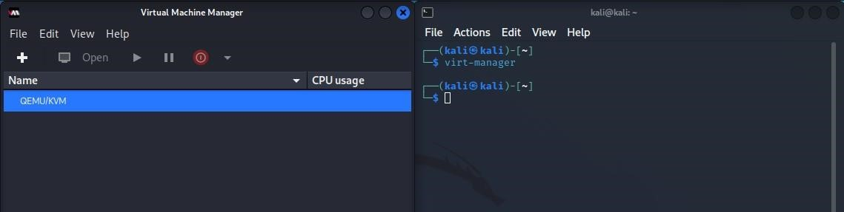

**PRACTICAL NO 6**

**AIM:** Develop application to download image/video from server or upload image/video to server using MTOM techniques.

If ASP.NET WEB Application is not present in Visual Studio Community 2022

**Step 1:** Open VS 2022 > Create a new project > Select ASP.NET Web Application (.Net Framework) using C# > Click on next > Write the project name > Create it.

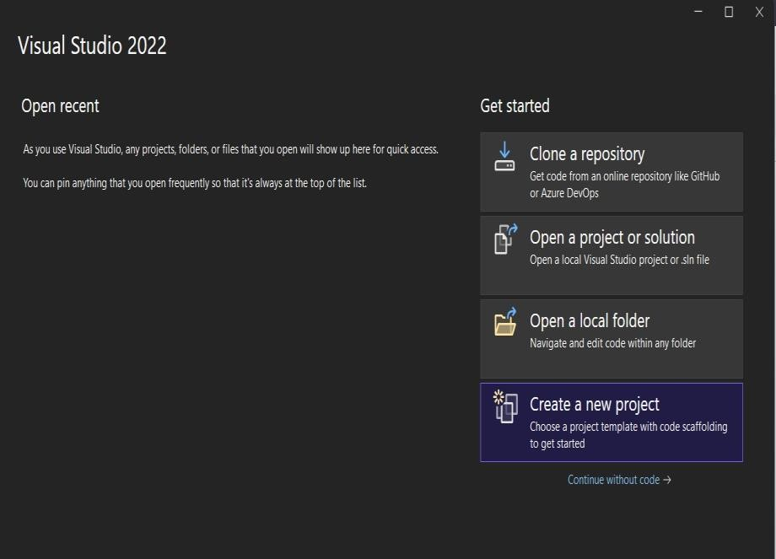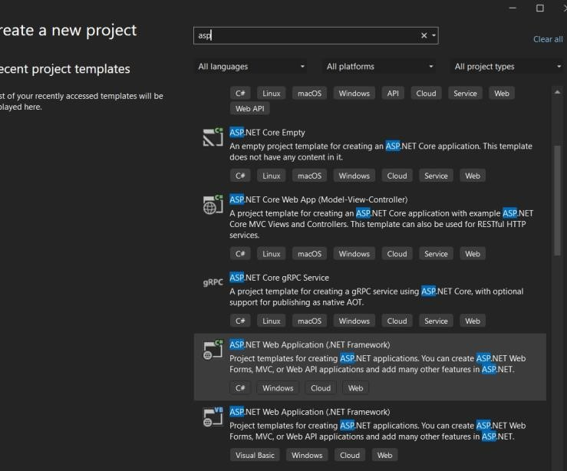

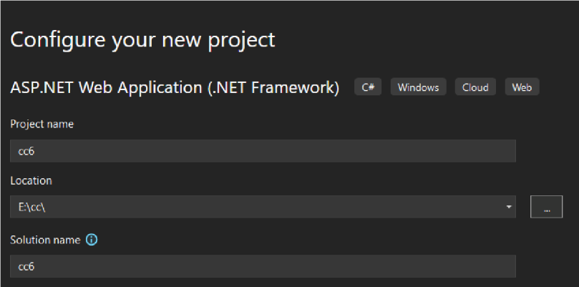

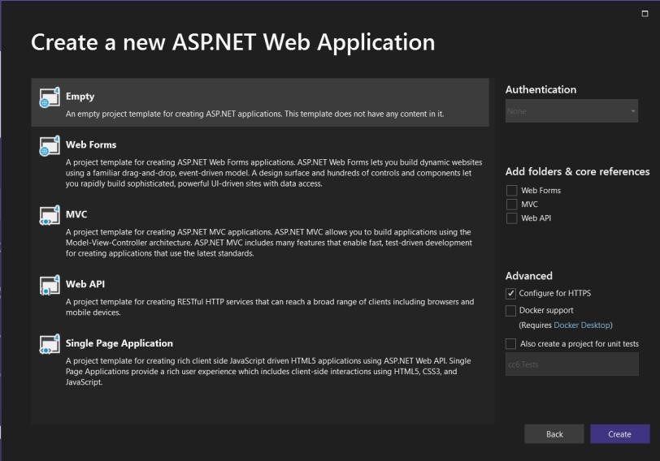

Step 2: Right click on project name > click on Add > Add New Item

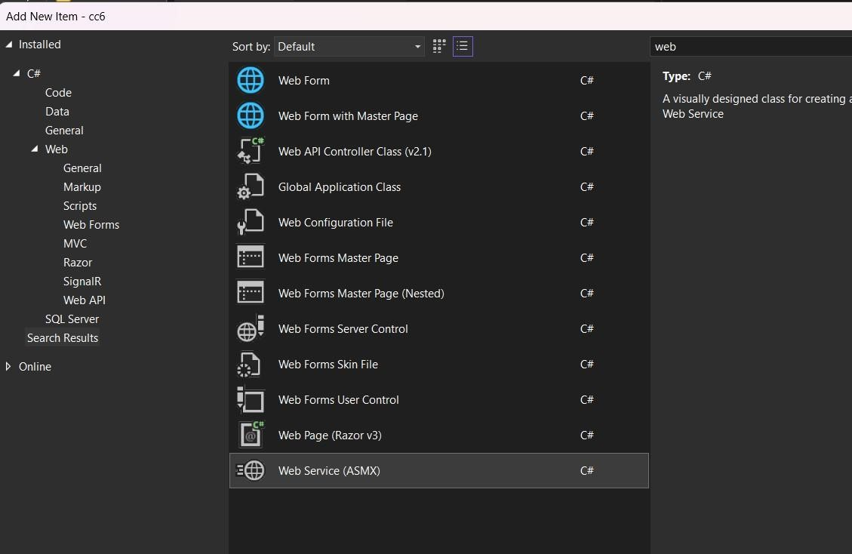

Below page will be open.

After that create one more Method following the below steps

For Error in Description click using System.ComponentModel;

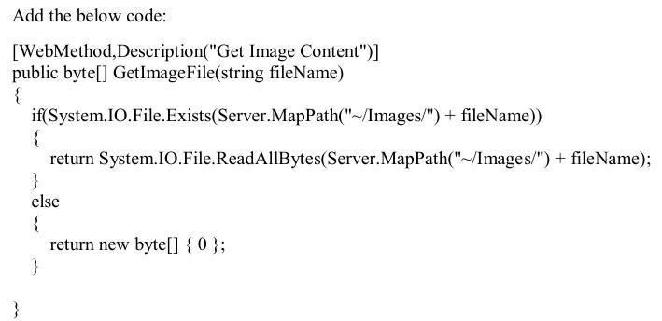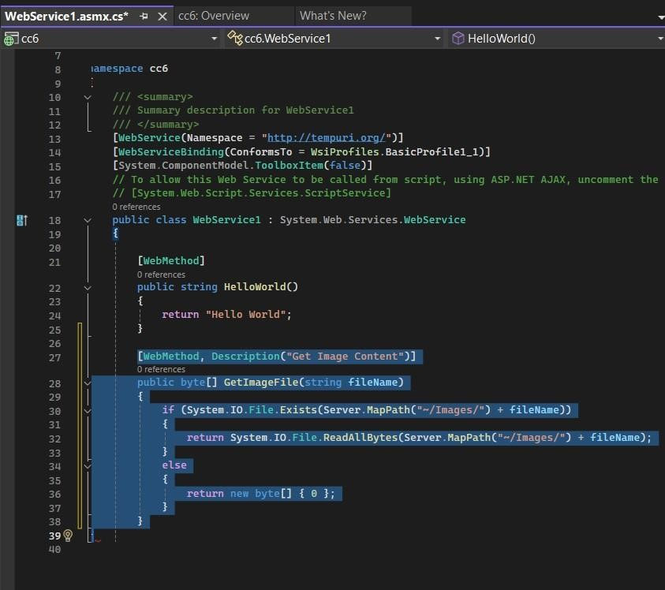

Use of this code: We are checking whether the file is present in the server or not using if else condition.

Step 3: Create a handler file > right click on project > Add > Add New Item > Search Handler.

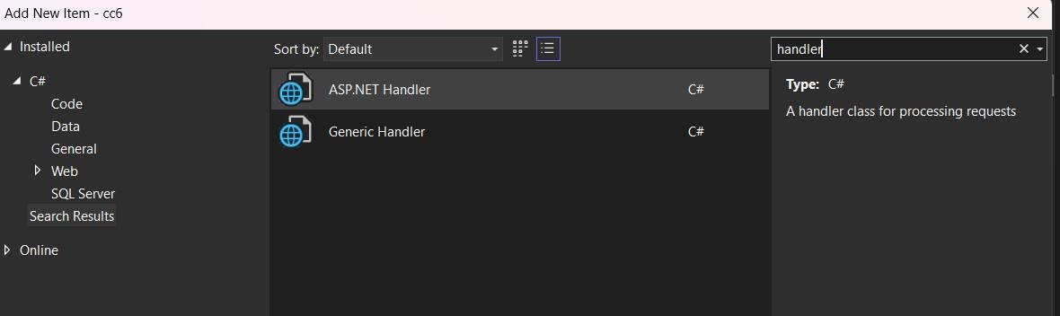

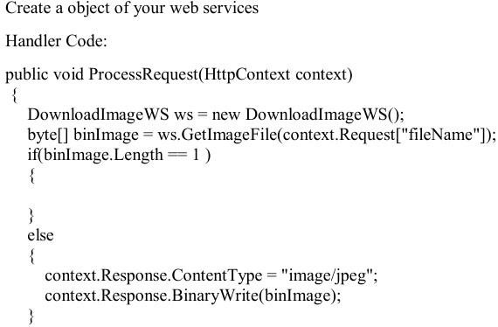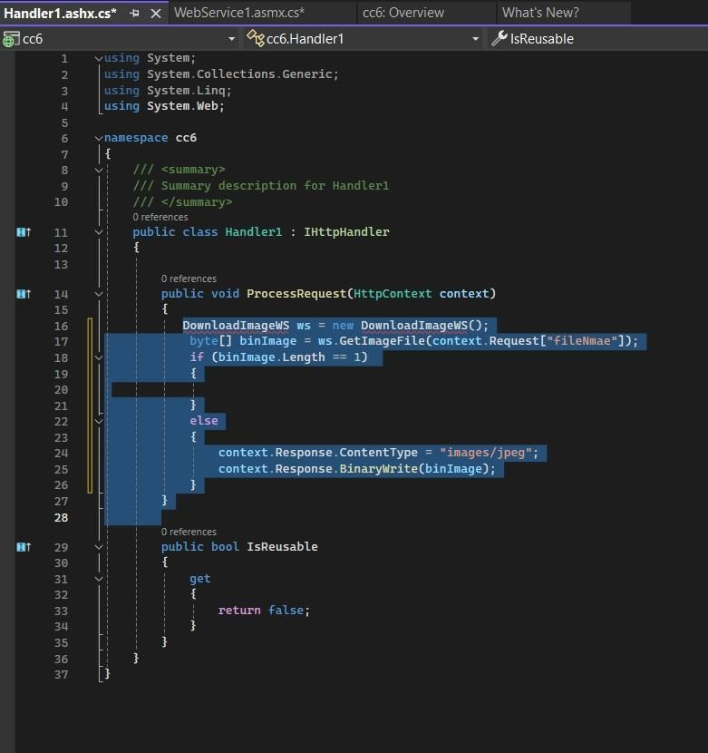

Step 4: Create a WEB FORM > right click on project > Add > Add New Item > Web Form.

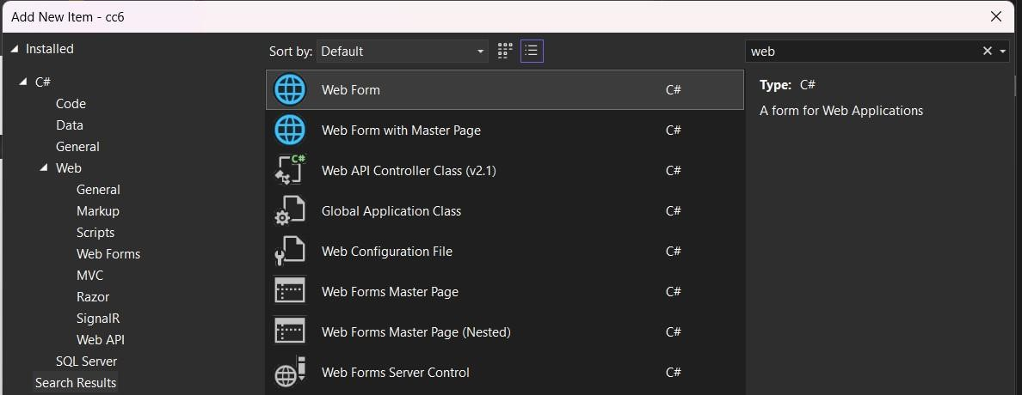

DownloadImage.aspx Form source code open and follow the below procedure:

Go to Design part > Search Bar > ToolBox > Add Label > Properties > Change the Text: Enter the Image Name > Border Style: Ridge.

Add TextBox > Properties > Change the ID: txt1 > Border Style: Groove.

Add Button > Properties > Change the ID: btn1 > Border Style: Ridge > Change the Text: Download the Image.

After Designing the Layout

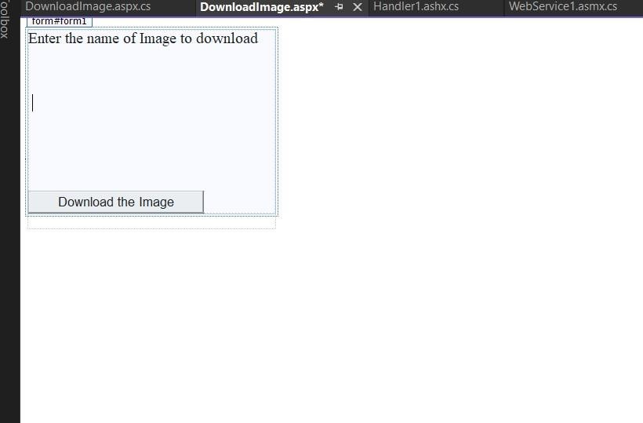

Double click on the Button Tab and write the below code: protected void btn1_Click(object sender, EventArgs e)

{

Image1.ImageUrl = "~/MyHandler.ashx?fileName=" + txt1.Text

Response.Write("Downloading of Image is done");

}

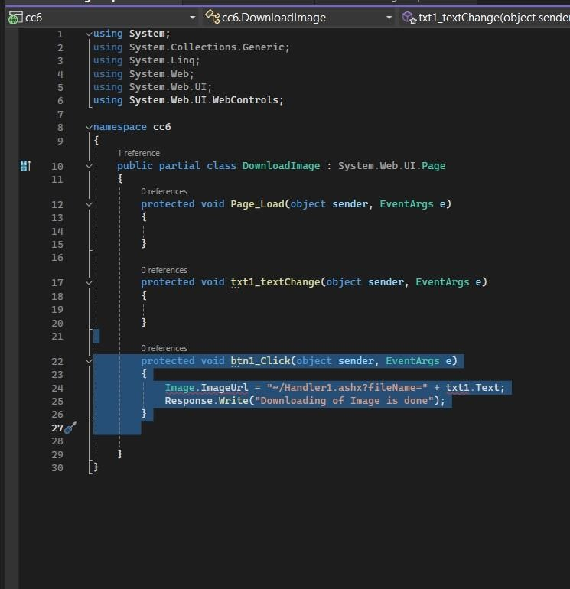

Step 5:

Images Part:

Now we require the images follow the step:

Right click on project > Add > Add Folder.

Rename folder as images.

Copy images > right click on the folder > paste it

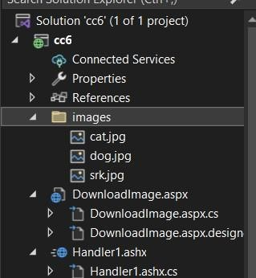

Save all the things > go to web form > right click > select open in web browser.

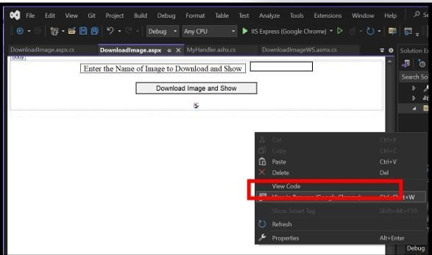

The Form will be open on Browser:

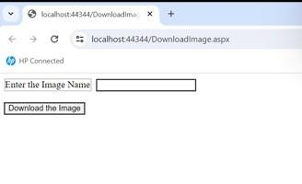

Enter the Image Name and click on the Button:

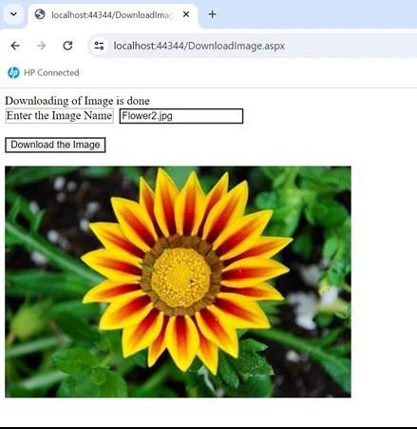

# PRACTICAL NO 7

**Aim: Implement FOSS-Cloud Functionality VSI (Virtual Server Infrastructure) Infrastructure as a Service (IaaS), Creating Virtual Machine or Storage Steps:**

**FOSS Cloud Installation**

1. Choose your keymap. 2. Confirm that you want to start: yes

1. Choose Demo-System: 1
2. Choose a Block-Device: sda
3. Confirm that you want to continue: yes
4. Confirm that you want to continue: yes
5. Choose the network interface: eth0
6. Choose if you want to use automatic network configuration: Yes
7. Reboot your system: yes
8. Login as root and run "fc-node-configuration -n demo-system --password admin"

**Note :- Above mentioned steps aren’t mandatory you can start with the installation process of virt-viewer as shown below.**

1. Install virt-viewer.
2. Install spice-client.0.6.3.
3. Open Browser.

Once you open browser then on the search type, 192.168.21.36

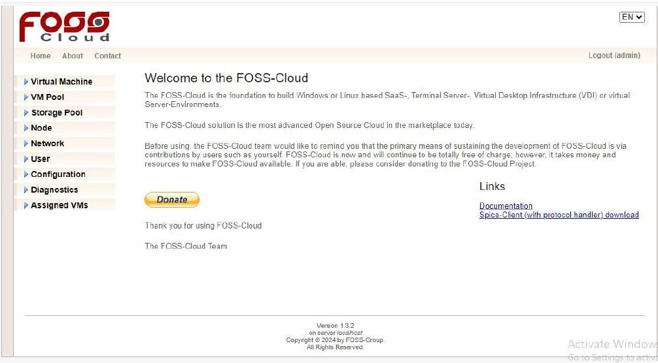

**Uploading ISO files to Foss cloud**

**Go to virtual machine->Profile->Upload ISO file->file name**

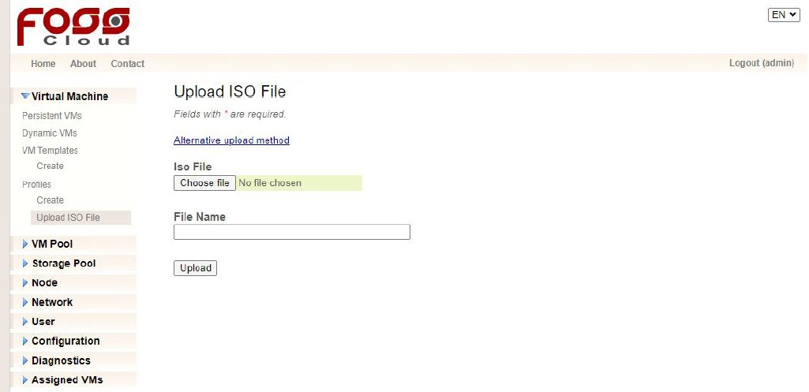

**Now choose the ubuntu-16.04.5-desktop-i386 iso-file from the FOSS cloud folder. Then, give your desired file name to it and click on the upload button.**

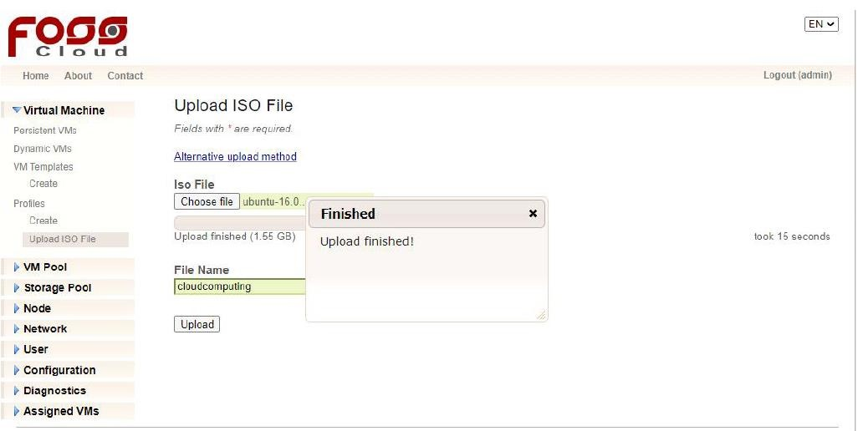

**Once done with the upload process go to the create section in profiles.**

**Creating a Profile**

The profile creates the relationship between the ISO file and the FOSS-Cloud.

1. Open Virtual Machines
2. Choose VM-Profiles
3. Choose the right Base Profile
4. Choose the right architecture (Windows only x86_64)
5. Chose the language (it is a information - not keyboard relevant)
6. Choose the ISO file (which you gave in file name tab)
7. Fill out name and description
8. Choose the amount of memory and volume capacity
9. Choose amount of CPU
10. Choose clock offset (normally Windows is "localtime" and Linux is "utc")

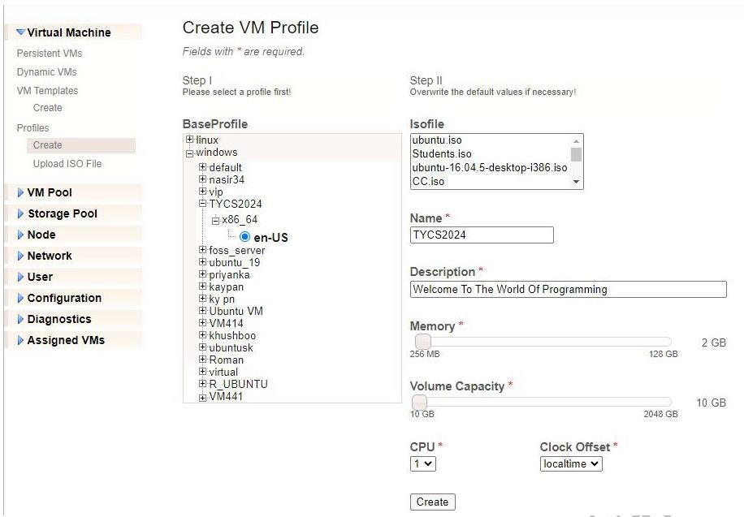

**Now, we will create a VM template.**

**Creating Template**

1. Choose the profile you have prepared before.
2. Add the VM-pool and one or more nodes, where you will run this VM (when the chosen

VMpool has only one node assigned, you don't have a choice)

1. You can change all the other information you have entered before

Click on "create" and the template is ready for installing the guest operating system.

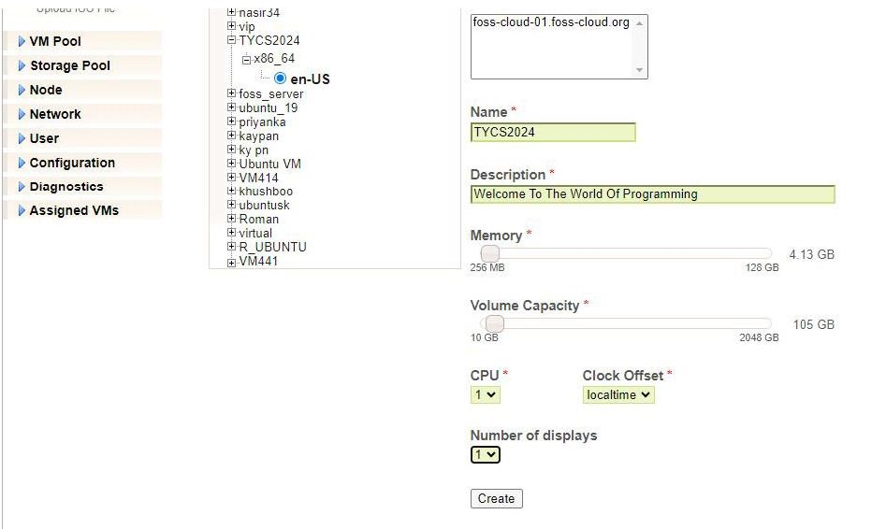

Once you create your virtual machine template you will be able to see your **VM template.**

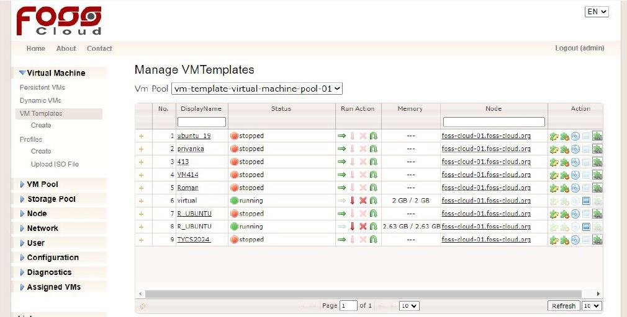

As you can see the last row of Display column our template is created.

To update your template status, click on the green arrow.

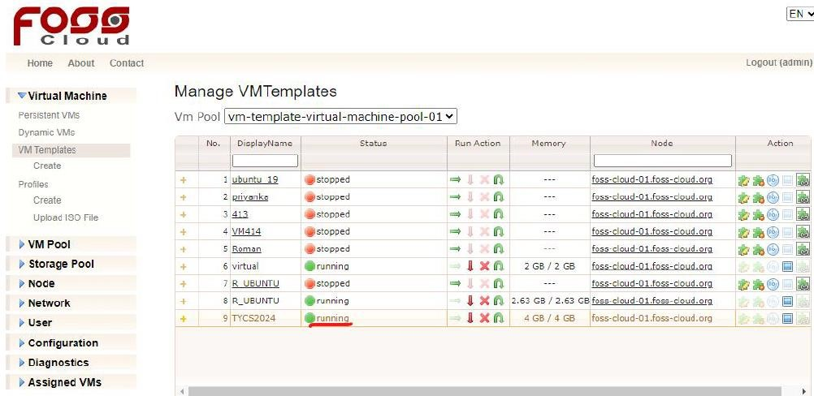

Now click on Use Template in Action column of your corresponding template.

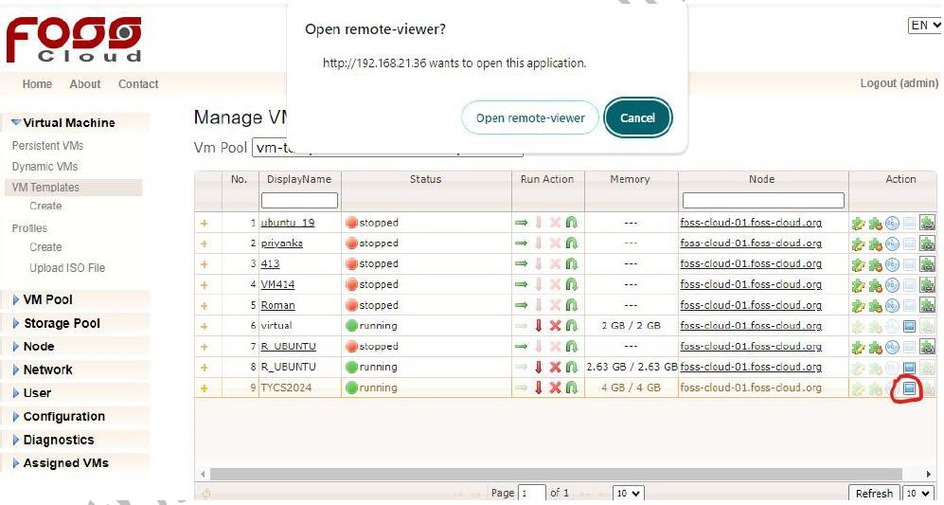

Just after clicking on, it a pop up would appear to Open remote-viewer? click on Openremote viewer button, you will see the following screen.

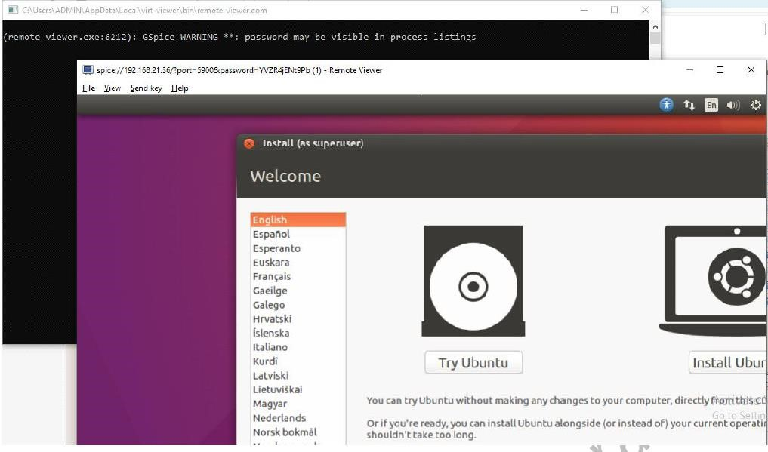

**Note :- If you don't see the above screen follow the below given steps.**

1.First press window + r, then type regedit and click ok.

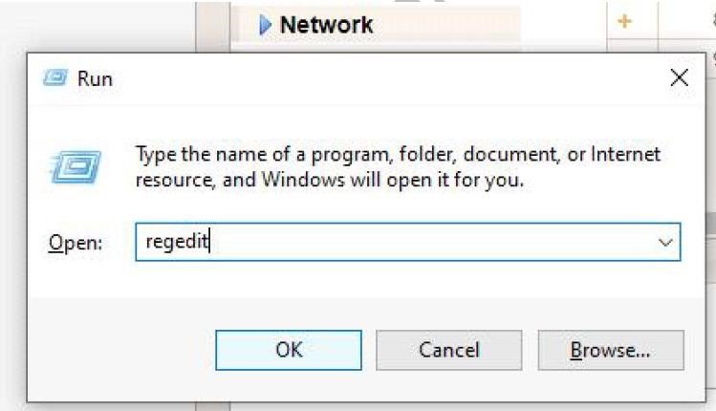

2.Further permissions tab will open then click yes, and a regedit editor will get open.

3.In the Registry Editor a list of directories would appear, in those lists of directories search for the spice directory.

4.Keep on expanding the spice directory until you reach the command section.

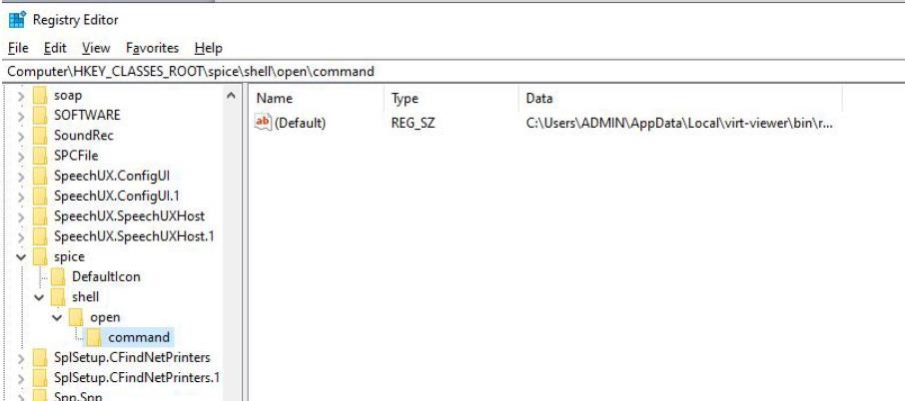

5. Then click on the default file and a pop up will appear, then you have to paste the path

**C:\Users\ADMIN\AppData\Local\virt-viewer\bin** in the value data and **also type %1 in last**.

Once done the above screen will appear.

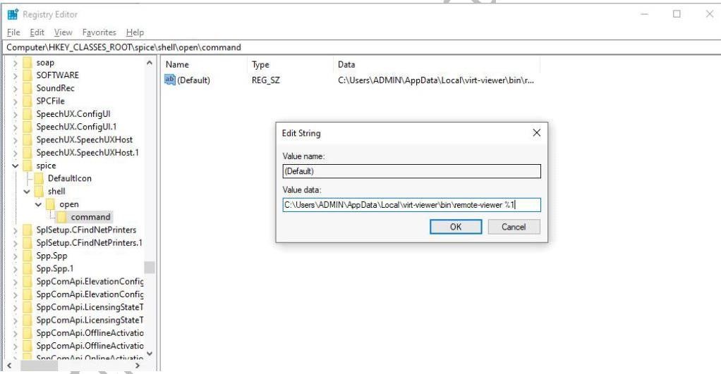

Finally, after clicking on remote viewer button a command line come where a graphical control loading and getting connected will be displayed and then finally the ubuntu will get open.

On opening of ubuntu click on try ubuntu. Now, you can use ubuntu on your virtual machine.

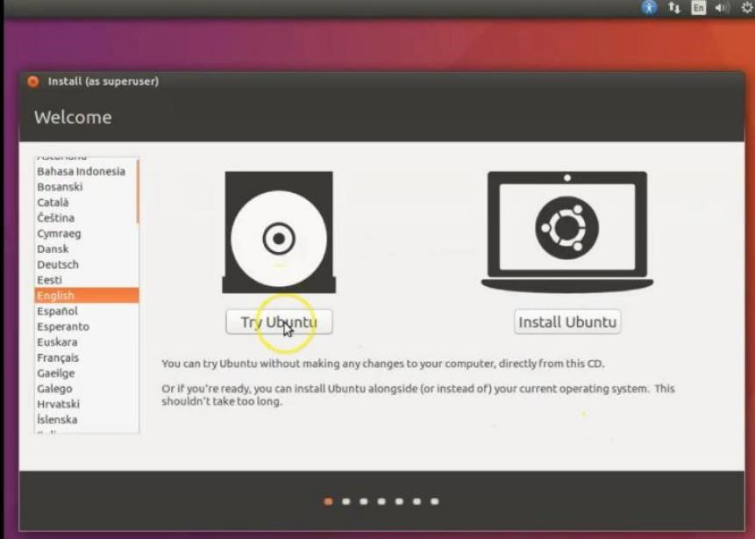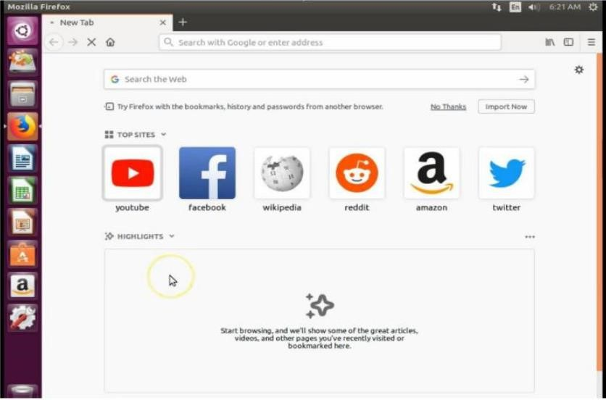

# PRACTICAL NO 8

**Aim: Implement FOSS-Cloud Functionality - VSI Platform as a Service (PaaS) Steps:**

Software development Kits can be made available in the Virtual Machines that can be implemented as Platform as a Service.

Installation of Netbeans, Eclipse, Visual Studio and DBMS can be done in the appropriate Virtual Machines.

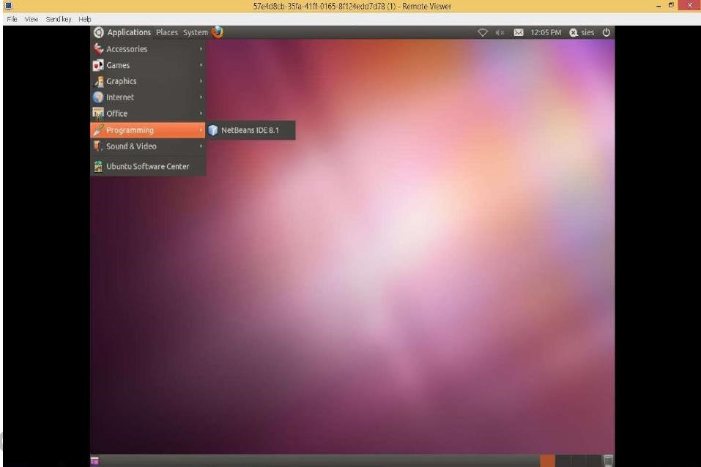

Applications created and deployed in the virtual machines can be accessed by outside world.

This can be implemented as Software as Service.

